Public Summary Document

Report to the Medical Services Advisory Committee on utilisation of MBS item 32023 following Application 1150: Insertion of colonic stents for the management of malignant bowel obstructions
Medicare Benefits Schedule (MBS) item considered: 32023
Date of MSAC consideration: 23 November 2017
Context for decision: MSAC makes its advice in accordance with its Terms of Reference, see the MSAC Website.

Purpose
The purpose of the report presented to the Medical Services Advisory Committee (MSAC) was to inform MSAC of the real world impacts on the outcomes of Application 1150. The MSAC uses this information to ensure that the new item/s resulting from this application/s is being used as intended.
The report is not intended to be a review of the clinical information covered during the application process.

MSAC’s advice
After considering the real world impacts of the outcomes of Application 1150 for the insertion of colonic stents for the management of malignant bowel obstructions (MBS item 32023), MSAC considered actual utilisation data and compared it with prior utilisation predictions following MSAC’s support for insertion of colonic stents for the management of malignant bowel obstructions. MSAC noted there was lower than expected utilisation of this item and recommended no further action.

Summary of consideration and rationale for MSAC’s advice
MSAC considered the real world impacts of the outcome of Application 1150 for the insertion of colonic stents for the management of malignant bowel obstructions (MBS item 32023) by examining the available data for this item number.
MSAC recalled that it was predicted that there would be 614 self-expanding metallic stent (SEMS) insertions in the period 2012–13, gradually increasing to 650 services for 2016–17. MSAC noted that actual utilisation of MBS item 32023 is significantly lower than the estimations in Application 1150, amounting to approximately 13% of predicted utilisation services for 2014–16. MSAC noted that colonic stenting procedures provided in public hospitals could be a factor in lower than expected utilisation of MBS item 32023.
MSAC considered the possibility of acquiring sales data from the medical devices industry in order to derive the number of services that are provided in the public hospital setting versus private sector.
MSAC recalled that it was estimated that 10% of patients would require re-stenting under MBS item 32023. MSAC noted that actual utilisation matched predicted for re-stenting as 9% of patients required two stent procedures and that there were some patients who required three stents over the five year period.
MSAC noted that there has been a gradual increase in the number of practitioners providing services under MBS item 32023. There were 37 practitioners in 2013–14, increasing to 53 practitioners in 2015–16. MSAC noted that 8% of services are being provided by specialists outside of the approved specialities. MSAC considered the possibility that these services were provided by general physicians or other specialists (outside of indicated specialties) under the direction of colorectal surgeons and gastroenterologists. MSAC noted that MBS item 32023 is currently restricted to colorectal surgeons and gastroenterologists who have undergone recognised training in gastrointestinal endoscopy
MSAC noted that the average fee charged for MBS item 32023 has increased from $702 in 2012–13 to $802 in 2016–17 and that private health insurance ‘no gap” or ‘known gap’ benefits may be utilised. MSAC also noted that roughly 50% of the total number of services since implementation was from New South Wales. MSAC noted that New South Wales had a significantly higher 95th percentile fee when compared with other States.
MSAC noted that MBS consultation items 104, 105, 110, 116, 119 and 132 are the items most commonly co-claimed with MBS item 32023. MSAC considered that this co-claiming was of no concern from a clinical perspective and are there are likely to be legitimate reasons for occasional co-claiming of these MBS items.
MSAC recommended no further action is required for MBS item 32023.

Methodology
An application is selected for consideration if the resulting new item(s) and/or item amendment(s) have been on the MBS for approximately 24 months or longer or if there were particular concerns about utilisation such that MSAC requested to consider it earlier. The specific applications for each MSAC meeting are selected by the MSAC Executive which is composed of the chairs of MSAC and its sub-committees.
A report on the utilisation is developed by the department with information on a number of metrics including; state variation, patient demographics, services per patient, practitioner’s providing the service, data on fees and co-claiming of services. The number of metrics included in a report is dependent on the annual service volume for the MBS item(s) under consideration i.e. an item with very low utilisation will have less data to analyse. Where service volumes are too low, information is suppressed to protect patient privacy.
Where possible the report compares data on real world utilisation to the assumptions made during the MSAC assessment. Most of these assumptions are drawn from the assessment report.
Relevant stakeholders are provided an opportunity to comment on the findings in the report before it is presented to the MSAC. It is intended that stakeholders are given at least three weeks to consider the reports.
The stakeholder version of the report does not contain information on assumptions from the MSAC consideration if this information is not already publicly available. This is to protect the commercial in confidence of the original applicants. The same principle is applied to this document.
Once MSAC has considered the report, its advice is made available online at the MSAC Website.

Results

Utilisation
Item 32023 had 81 services claimed in 2014-15 and 85 services claimed in 2015-16. Month to month growth in use of this item suggests this service has reached a plateau.
From 1 November 2012 to 31 March 2017, New South Wales had the highest utilisation with 149 services (approximately half of total services billed to the item). There were 83 services in Queensland and 32 services in Victoria in the same period (Table 1).

Table 1: Service volume of MBS item 32023 between 2012-13 and 2016-17 (date of service)
 | State/Territory |  |  |  |  |  |  |  | Total
 | NSW | VIC | QLD | SA | WA | TAS | NT | ACT
2012-2013 | np | np | np | np | np | np | np | np | 12
2013-2014 | 28 | 7 | 16 | np | np | np | np | np | 57
2014-2015 | 43 | np | 22 | np | np | np | np | np | 81
2015-2016 | 36 | 13 | 20 | 7 | 9 | np | np | np | 85
2016-2017* | 37 | 7 | 22 | np | np | np | np | np | 71
All years | 149 | 32 | 83 | 14 | 19 | np | np | np | 306
Source: MBS Analytics Section – May 2017
*2016-17 financial year includes data to 31 March 2017
NP = not printed to protect privacy

Patient breakdown
There were 80 patients who claimed 85 services for item 32023 in 2015-16. Of these, 74 were new patients and 6 were continuing from the previous financial year. Figures suggest these continued and the consequent additional services are consistent with the predictions made regarding re-stenting because of stent failure, re-obstruction or migration of the initial stent insertion (Table 2). The minor submission to MSAC estimated that approximately 10% of patients would require re-stenting.
In 2016-17, 11% of patients received two or more services under item 32023 (Table 3).
It is consistent that some patients have received two or more services since the listing of the item (Table 4).
The service is predominantly claimed by patients aged 55-84. A small number of services have been provided to adults aged 24 or below (Figure 1).

Table 2: Number of new and continuing patients who received MBS item 32023 by financial year
Financial  Year | Total |  | New |  | Continuing
 | Patients | Services | Patients | Services | Patients | Services
Total | 272 | 306 | - | - | - | -
2012-13 | 11 | 12 | 11 | 12 | - | -
2013-14 | 52 | 57 | 52 | 57 | - | -
2014-15 | 78 | 81 | 78 | 81 | - | -
2015-16 | 80 | 85 | 74 | 77 | 6 | 8
2016-17* | 64 | 71 | 57 | 62 | 7 | 9

Table 3: Number of services per patient in 2015-16 and 2016-17*
Financial | Services | Count | Percentage
2015-16 | 1 | 75 | 94%
 | 2 | 5 | 6%
2016-17* | 1 | 57 | 89%
 | 2 | 7 | 11%
*2016-17 data until 31 march 2017, and does not constitute a complete financial year

Table 4: Number of services per patient since service listed 1 November 2012 to 31 March 2017
Services per Patient | Count | Percentage
Total | 272 | 100%
1 | 243 | 89%
2+ | 29 | 11%
Source for tables 2-4: Department of Health, File: Q20784 Item 32023 utilisation.xlsx
- 2013-14
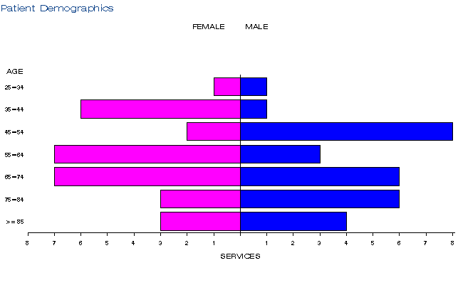
- 2014-15
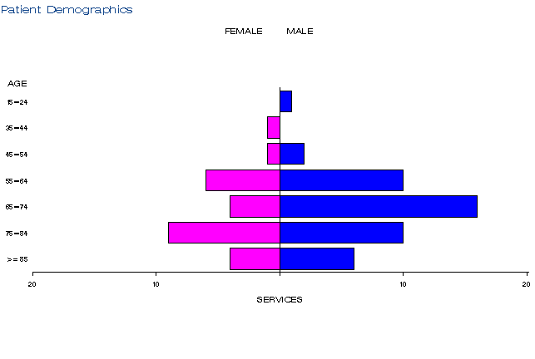
c) 2015-16 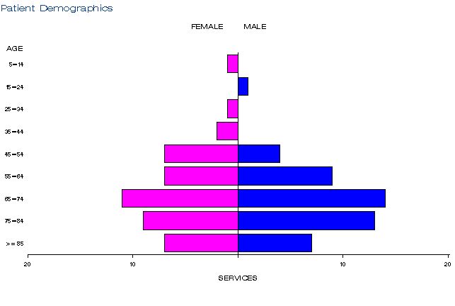
d) 2016-17
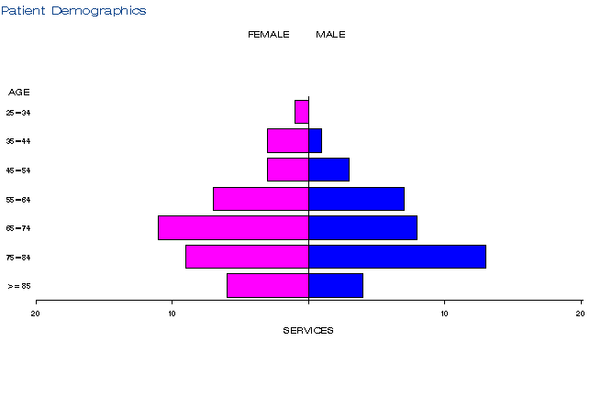
Figure 1: Demographic profile for MBS item 32023 for 2013-14 (a), 2014-15 (b), 2015-16 (c) and 2016-17 (d)
Source: Medicare Statistics Online

Practitioner breakdown
There has been a gradual increase in the number of practitioners providing services under item 32023. There were 37 practitioners in 2013-14, increasing to 53 practitioners in 2015-16 (Table 5). About 25% of practitioners have provided close to 60% of all services (Table 6). Close to 55% of services were provided by Gastroenterology and Hepatology specialists, and 92% of services provided by gastroenterologists and general surgeons.
While the item is restricted to colorectal surgeons and gastroenterologists with endoscopic training who are recognised by the Conjoint Committee for the Recognition of Training in Gastrointestinal Endoscopy only, data indicates a low volume of services are being provided by specialists in obstetrics and gynaecology. However, given the data is based on provider billing behaviour (i.e. derived specialty as opposed to registered specialty), it is possible that these services were provided by colorectal surgeons and gastroenterologists, but not classified as such in the data.

Table 5: Number of practitioners providing services under item 32023 in 2012-13 to 2016-17
Financial year | Practitioners | Services | Average
2012-13 | 11 | 12 | 1.1
2013-14 | 37 | 57 | 1.5
2014-15 | 47 | 81 | 1.7
2015-16 | 53 | 85 | 1.6
2016-17* | 42 | 71 | 1.7
All Years | 118 | 306 | 2.6
Table 6: Cumulative percentage of medical practitioners providing item 32023 and how many services each percentile accounts for in 2012-13 to 2016-17
Provider Cumulative % | 2012-13 | 2013-14 | 2014-15 | 2015-16 | 2016-17 (to 31 Mar 17) | All Years
5% | - | 21.2 | 15.3 | 17.2 | 13.2 | 24.9
10% | 17.5 | 30.5 | 26.9 | 28.1 | 24.8 | 37.8
20% | 26.7 | 43.5 | 46.7 | 41.4 | 42.5 | 54.5
25% | 31.3 | 50.0 | 52.5 | 47.6 | 49.3 | 60.3
30% | 35.8 | 54.6 | 58.3 | 53.9 | 55.2 | 66.1
40% | 45.0 | 61.1 | 65.2 | 62.6 | 64.5 | 74.0
50% | 54.2 | 67.5 | 71.0 | 68.8 | 70.4 | 80.7
60% | 63.3 | 74.0 | 76.8 | 75.1 | 76.3 | 84.6
70% | 72.5 | 80.5 | 82.6 | 81.3 | 82.3 | 88.4
75% | 77.1 | 83.8 | 85.5 | 84.4 | 85.2 | 90.4
80% | 81.7 | 87.0 | 88.4 | 87.5 | 88.2 | 92.3
90% | 90.8 | 93.5 | 94.2 | 93.8 | 94.1 | 96.1
95% | 95.4 | 96.8 | 97.1 | 96.9 | 97.0 | 98.1
99% | 99.1 | 99.4 | 99.4 | 99.4 | 99.4 | 99.6
Source for tables 5-6: Department of Health, File: Q20784 Item 32023 provider concentration.xlsx

Co-claiming
The service (approximately 65% of episodes) is commonly claimed with specialist consultation items 104, 105, 110, 116, 119, and 132 (Table 7-9).
As of November 1 2017, Medical practitioners will no longer be able to claim MBS benefits for subsequent attendance items 105, 116, and 119 if they are claiming any Group T8 items with a schedule fee of equal to or greater than $300 on the same day. Medical practitioners who are not claiming subsequent attendance items with Group T8 items will not be affected. Three new items will be introduced for subsequent attendances that are urgent and not able to be predicted. These new items can be claimed on the same day as Group T8 items with schedule fees of equal to or greater than $300.
Departmental medical advice noted there was no concern from a clinical perspective as to the other MBS items that were co-claimed in this dataset. The numbers were small and there are likely to be legitimate reasons for the MBS items when only utilised occasionally.

Table 7: Top 10 instances of co-claiming with MBS item 32023 in 2014-15
# | Items | Episodes | Services | Schedule Fee for combination | Number of providers | Number of patients | % of episodes
1 | 32023 | 31 | 31 | $ 17,216 | 22 | 30 | 38.27%
2 | 32023, 110 | 17 | 34 | $12,006 | 12 | 17 | 20.99%
3 | 32023, 105 | 12 | 24 | $7,180 | 8 | 12 | 14.81%
4 | 32023, 116 | np | 14 | $4,416 | np | np | 8.64%
5 | 32023, 104 | np | 12 | $3,845 | np | np | 7.41%
6 | 32023, 119 | np | np | $1,197 | np | np | 2.47%
7 | 32023, 104,105 | np | np | $684 | np | np | 1.23%
8 | 32023, 104, 30473, 32072 | np | np | $777 | np | np | 1.23%
9 | 32023, 105, 30473 | np | np | $687 | np | np | 1.23%
10 | 32023, 110, 30473 | np | np | $795 | np | np | 1.23%

Table 8: Top 10 instances of co-claiming with MBS item 32023 in 2015-16
# | Items | Episodes | Services | Schedule Fee for combination | Number of providers | Number of patients | % of episodes
1 | 32023 | 24 | 24 | $13,328 | 19 | 23 | 28.24%
2 | 32023, 110 | 21 | 42 | $14,831 | 15 | 21 | 24.71%
3 | 32023, 116 | 14 | 28 | $8,832 | 11 | 14 | 16.47%
4 | 32023, 105 | 10 | 21 | $6,027 | np | 9 | 11.76%
5 | 32023, 104 | np | 10 | $3,205 | np | np | 5.88%
6 | 32023, 132 | np | 8 | $3,277 | np | np | 4.71%
7 | 32023, 61109 | np | np | $1,619 | np | np | 2.35%
8 | 32023, 105, 34527 | np | np | $874 | np | np | 1.18%
9 | 32023, 30473 | np | np | $644 | np | np | 1.18%
10 | 32023, 32135 | np | np | $589 | np | np | 1.18%

Table 9: Top 10 instances of co-claiming with MBS item 32023 in 2016-17 (to 31 Mar 17)
# | Items | Episodes | Services | Schedule Fee for combination | Number of providers | Number of patients | % of episodes
1 | 32023 | 24 | 24 | $13,328 | 17 | 23 | 33.80%
2 | 32023, 110 | 12 | 24 | $8,475 | 8 | 12 | 16.90%
3 | 32023, 105 | 10 | 20 | $5,984 | 8 | 9 | 14.08%
4 | 32023, 116 | 9 | 18 | $5,678 | 8 | 9 | 12.68%
5 | 32023, 104 | 8 | 16 | $5,127 | np | 8 | 11.27%
6 | 32023, 105, 30473 | np | np | $687 | np | np | 1.41%
7 | 32023, 32030, 35720 | np | np | $2,010 | np | np | 1.41%
8 | 32023, 105, 34527 | np | np | $874 | np | np | 1.41%
9 | 32023, 116, 30473 | np | np | $719 | np | np | 1.41%
10 | 32023, 133 | np | np | $687 | np | np | 1.41%
Source for Tables 7-9: Department of Health, File: Q20784 Item 32023 combination.xlsx

NP = not printed to protect privacy

Data on fee charged
The information provided on fees below is a snapshot of how the item is being claimed in practice. Data has not been printed for states and territories with low service volumes.
The 75% benefit for item 32023 is $416.55.
The average fee charged for item 32023 has increased from $702 in 2012-13 to $802 in 2016-17 (Table 10). The 95th percentile fee charged in NSW which was $1,000 in 2014-15 and $1420 in 2016-17, significantly higher than other states, which ranged from $751 to $855. Services are generally not bulk billed, although in NSW in 2014-15, 2.3% of services were. It is likely that Private Health Insurance and “no gap” or “known gap” arrangements may be utilised for this service.

Table 10: Statistics on fees charged for MBS item 32023 for 2014-15 to 2016-17 by date of service
 |  | Provider State/Territory
 |  | NSW | Vic | Qld | SA | WA | TAS | NT | ACT | AUS
2014-15 | Average Fee Charged | $752.42 | $679.63 | $755.94 | $800.25 | $701.01 | np | np | np | $750.78
 | Standard  Deviation | $167.28 | $217.20 | $157.88 | $57.17 | $95.47 | np | np | np | $152.91
 | Median | $742.25 | n/a (4) | n/a (4) | n/a (4) | n/a (4) | np | np | np | $766.20
 | 75th Percentile | $777.50 | n/a (4) | n/a (4) | n/a (4) | n/a (4) | np | np | np | $777.50
 | 95th Percentile | $1,000.00 | n/a (4) | n/a (4) | n/a (4) | n/a (4) | np | np | np | $1000.00
 | Bulk Billed  Rate | 2.3% | - | - | - | - | np | np | np | 1.2%
2015-16 | Average Fee Charged | $712.34 | $735.51 | $800.91 | $818.92 | $759.27 | np | np | np | $750.47
 | Standard  Deviation | $138.92 | $106.62 | $138.15 | $66.00 | $2.60 | np | np | np | $126.31
 | Median | $730.80 | n/a (4) | n/a (4) | n/a (4) | n/a (4) | np | np | np | $758.40
 | 75th Percentile | $766.20 | n/a (4) | n/a (4) | n/a (4) | n/a (4) | np | np | np | $777.50
 | 95th Percentile | $1,016.20 | n/a (4) | n/a (4) | n/a (4) | n/a (4) | np | np | np | $879.55
 | Bulk Billed  Rate | - | - | - | - | - | np | np | np | 0%
2016-17  (to 31 Mar 17) | Average Fee Charged | $846.07 | $745.51 | $762.74 | - | np | np | np | np | $802.14
 | Standard  Deviation | $617.67 | $24.68 | $51.00 | - | np | np | np | np | $446.98
 | Median | $730.80 | n/a (4) | n/a (4) | n/a (4) | n/a (4) | np | np | np | $760.85
 | 75th Percentile | $766.20 | n/a (4) | n/a (4) | n/a (4) | n/a (4) | np | np | np | $780.60
 | 95th Percentile | $1,420.00 | n/a (4) | n/a (4) | n/a (4) | n/a (4) | np | np | np | $1110.85
 | Bulk Billed  Rate | - | - | - | - | - | np | np | np | 0%
Source: Department of Health, File: Q20784 Item 32023 utilisation 24 MAY 17.xls
NP = not printed to protect privacy
n/a(4) = data not included

Background
MBS item 32023 for the insertion of colonic stents for the management of malignant bowel obstructions was listed onto the MBS on 1 March 2013.
In October 2010, the Department of Health and Ageing received an application from the Colorectal Surgical Society of Australia and New Zealand (CSSANZ) requesting Medicare Benefit Schedule (MBS) listing of colonic stents for the management of large bowel obstruction.
MSAC’s role was to assess the safety, effectiveness and efficacy, cost-effectiveness of insertion of colonic SEM stents. MSAC would also consider the wording of the MBS item descriptor, the MBS fee and the financial implications of publicly funding the surgical procedure.
The applicant advised that if an obstruction or stenosis becomes reduced in size, a stent would simply fall out, as stents generally required an obstruction to stay in place. This may also occur in the case of stent migration, where re-intervention involving the removal of the migrated stent and the deployment of a new SEMS is required. Therefore, there was no need to have a specific MBS item number for stent removal. In the case of a failed attempt at stent insertion, existing MBS item 30001 (abandoned surgery), where 50 per cent of the usual fee is paid, may be claimed for the procedure.
The MSAC supported the listing of the service onto the MBS at its November 2012 meeting.
The MBS service is restricted to colorectal surgeons or gastroenterologists with endoscopic training who are recognised by the Conjoint Committee for the Recognition of Training in Gastrointestinal Endoscopy. However, this is in T8.17 of the explanatory notes and not a regulatory restriction in the General Medical Services Table.

Item descriptor
32023 | Endoscopic insertion of stent or stents for large bowel obstruction, stricture or stenosis, including colonoscopy and any image intensification, where the obstruction is due to:  a) a pre-diagnosed colorectal cancer, or cancer of an organ adjacent to the bowel; or  b) an unknown diagnosis  Multiple Services Rule  (Anaes.)  Fee: $555.35 Benefit: 75% = $416.55  (See para T8.17 of explanatory notes to this Category)

Applicant’s comments on MSAC’s public summary document
The applicant had no comment

Further information on MSAC
MSAC Terms of Reference and other information are available on the MSAC Website at: www.msac.gov.au.

The 95th percentile fee charged represents that 95% of the time the fee is at or below this amount but in 5% of cases, the fee is higher than this.

