1242
Final Decision Analytic Protocol (DAP) to guide the assessment of the use of Y90- microspheres in patients with hepatic primary and secondary cancers
September 2012

Table of Contents
MSAC and PASC 2
Purpose of this document 2
Summary of matters for consideration by the applicant 3
Purpose of application 3
Background 4
Current arrangements for public reimbursement 4
Previous MSAC reviews of SIR-Spheres 8
2003 MSAC review 8
Regulatory status 10
Intervention 10
Description 10
Medical condition 11
Primary Liver Cancer 11
Metastatic Liver Cancer 11
Delivery of the intervention 12
Dose, frequency of administration and duration of treatment 14
Prerequisites 15
Co-administered and associated interventions 17
Primary Liver Cancer 24
Metastatic Liver Cancer 25
Listing proposed and options for MSAC consideration 27
Proposed MBS listing 27
Patient population 29
Clinical place for proposed intervention 31
Primary Liver Cancer 31
Colorectal liver metastases 34
Comparator 37
Clinical claim 38
Proposed structure of economic evaluation (decision-analytic) 39
Primary Liver Cancer 40
Metastatic Liver Cancer 42
Outcomes and health care resources affected by introduction of proposed intervention 45
Clinical outcomes 45
Health care resources 46
References 47

MSAC and PASC

The Medical Services Advisory Committee (MSAC) is an independent expert committee appointed by the Minister for Health and Ageing (the Minister) to strengthen the role of evidence in health financing decisions in Australia. MSAC advises the Minister on the evidence relating to the safety, effectiveness, and cost-effectiveness of new and existing medical technologies and procedures and under what circumstances public funding should be supported.

The Protocol Advisory Sub-Committee (PASC) is a standing sub-committee of MSAC. Its primary objective is the determination of protocols to guide clinical and economic assessments of medical interventions proposed for public funding.

Purpose of this document

This document is intended to provide a decision analytic protocol that will be used to guide the assessment of an intervention for a particular population of patients. This protocol has been developed incorporating advice from relevant stakeholders.

The protocol guiding the assessment of the health intervention has been developed using the widely accepted “PICO” approach. The PICO approach involves a clear articulation of the following aspects of the question for public funding that the assessment is intended to answer:

Patients – specification of the characteristics of the patients in whom the intervention is to be considered for use

Intervention – specification of the proposed intervention and how it is delivered

Comparator – specification of the therapy most likely to be replaced by the proposed intervention

Outcomes – specification of the health outcomes and the healthcare resources likely to be affected by the introduction of the proposed intervention

Summary of matters for consideration by the applicant

The PASC requests that the applicant note the following issues and consider addressing the issues in its application:

• PASC notes that the proposed population is broader than the population covered by the current MBS listing. In particular, PASC noted the proposal to extend the metastatic disease indication to include non-colorectal liver metastases. PASC considered that it would be appropriate for an application to request MBS items that covered the broader population however evidence demonstrating the comparative effectiveness and safety of SIRT in patients with non-colorectal liver metastases versus the appropriate comparator would need to be presented to support such an extension of the current listing of SIRT.

Purpose of application

A proposal for an application requesting MBS listing of Yttrium-90 MicrospheresTM (Y90-microspheres) for administration via trans-femoral catheterisation of the hepatic artery to embolise the microvasculature of, and deliver internal beta-radiation therapy to, hepatic primary and secondary cancers was received from Sirtology Pty Ltd by the Department of Health and Ageing in December
2011.

This proposal relates to a new intervention; however, selective internal radiation spheres (SIR- Spheres) have been interim listed on the MBS since May 2006 (items 35404, 35404, and 35408). This interim listing was due to expire in May 2011 but it has been maintained. SIR-Spheres are made by a separate manufacturer but are identical to Y90-microspheres in all physical respects.

The applicant attached a cover letter requesting that the wording (SIR-Spheres) in the interim MBS listings be treated as a generic term rather than the trademarked name of a particular brand. This would allow the MBS items to be interpreted as describing a medical service without restricting the service to a single product.

It is recognised that SIR-Spheres can be thought of as both a generic name deriving from selective internal radiation therapy (SIRT) and as a trademarked product. Throughout this DAP the wording “SIR-Spheres” refers to the MBS interim listed competitor product (except in MBS item descriptors and MSAC reviews where the committee may be intending to describe the service rather than the specific product) and the wording “Y90-microspheres” refers to the current product under consideration. “Radioembolisation” and “SIRT” are used as general terms describing the generic intervention.

Background

Current arrangements for public reimbursement
SIR-Spheres have been interim-listed on the MBS since May 2006. The application states that the resin-based yttrium-90 microspheres produced by Sirtex Medical Limited (SIR-SpheresTM) and Sirtology Pty Ltd (Y90-Microspheres™) are identical. Both products are also the same product that was described by Bruce Gray in 1983 and first used in patients in 1986. Similarities include:

• The raw microspheres from which both products are made are the same (4% cross linked polystyrene divinylbenzene copolymer).

• The raw microspheres used to produce both products are sourced and manufactured identically by the same company (BioRad Laboratories in Hercules California USA via the subsidiary BioRad Laboratories Pty Ltd in New South Wales). BioRad also obtains the raw starting materials for both products from the same source.

• Both microspheres products contain the same isotope: yttrium-90.
• Both Sirtex Medical Limited and Sirtology Pty Ltd obtain the yttrium-90 from the same source; Perkin Elmer in USA.
• Both products are designed to treat patients with advanced liver cancer that is not amenable to surgical resection or regional ablation.

• Both products rely on the same clinical trial evidence. The Australian randomised clinical trial data are owned and controlled by Bruce Gray.
• Both products are delivered to the patients by the exact same technique of SIRT (also called radio-embolisation).
• Both products are manufactured using the same wet chemistry processes that were first described by Bruce Gray in 1983 and using the exact same input materials.
• The quality inspection processes during manufacture for both products are the same.

• Both microspheres products are spherical and are the same size; mean diameter 32-33μ

• Both microspheres products are the same density (SG ~1.6)

• The reaction cells used for production for both products are manufactured by Gray Surgical, a private medical device company of the principal of Sirtology Pty Ltd.
• Both products use identical ancillary devices for delivery of the radioactive microspheres to the patient; V-Vial, V-Vial Holder, Delivery Set and DeliveryBox.
• Both products are classified as Class-3 Active Implantable Medical devices.

• Both products are shipped in Type-A registered Dangerous Goods packaging.

• Neither product is patentable.

SIR-Spheres are listed on the MBS for interim reimbursement with the following item descriptors presented in Tables 1, 2 and 3.

Table 1: Current MBS item descriptor for item 35404
Category 3 – THERAPEUTIC PROCEDURES
MBS 35404
DOSIMETRY, HANDLING AND INJECTION OF SIR-SPHERES for selective internal radiation therapy of hepatic metastases which are secondary to colorectal cancer and are not suitable for resection or ablation, used in combination with systemic chemotherapy using 5-fluorouracil (5FU) and leucovorin, not being a service to which item 35317, 35319,
35320 or 35321 applies

The procedure must be performed by a specialist or consultant physician recognised in the specialties of nuclear medicine or radiation oncology on an admitted patient in a hospital. To be claimed once in the patient's lifetime only.

Multiple Services Rule T8.2

Fee: $340.15 Benefit: 75% = $255.15

EXPLANATORY NOTES - Selective Internal Radiation Therapy (SIRT) using SIR-Spheres - (35404, 35406 and 35408) These items were introduced into the Schedule on an interim basis in May 2006 following a recommendation of the Medical Services Advisory Committee (MSAC). Medicare funding for these items is available until May 2011, before which time MSAC will review the results of trials conducted in the intervening period. SIRT should not be performed in an outpatient or day patient setting to ensure patient and radiation safety requirements are met.

Table 2: Current MBS item descriptor for item 35406
Category 3 – THERAPEUTIC PROCEDURES
MBS 35406
Trans-femoral catheterisation of the hepatic artery to administer SIR-Spheres to embolise the microvasculature of hepatic metastases which are secondary to colorectal cancer and are not suitable for resection or ablation, for selective internal radiation therapy used in combination with systemic chemotherapy using 5-fluorouracil (5FU) and leucovorin, not being a service to which item 35317, 35319, 35320 or 35321 applies excluding associated radiological services or preparation, and excluding aftercare

Multiple Services Rule T8.2 (Anaes.) (Assist.)
Fee: $798.15 Benefit: 75% = $598.65

EXPLANATORY NOTES - Selective Internal Radiation Therapy (SIRT) using SIR-Spheres - (35404, 35406 and 35408) These items were introduced into the Schedule on an interim basis in May 2006 following a recommendation of the Medical Services Advisory Committee (MSAC). Medicare funding for these items is available until May 2011, before which time MSAC will review the results of trials conducted in the intervening period. SIRT should not be performed in an outpatient or day patient setting to ensure patient and radiation safety requirements are met.

Table 3: Current MBS item descriptor for item 35408
Category 3 – THERAPEUTIC PROCEDURES
MBS 35408
Catheterisation of the hepatic artery via a permanently implanted hepatic artery port to administer SIR-Spheres to embolise the microvasculature of hepatic metastases which are secondary to colorectal cancer and are not suitable for resection or ablation, for selective internal radiation therapy used in combination with systemic chemotherapy using 5-fluorouracil (5FU) and leucovorin, not being a service to which item 35317, 35319, 35320 or 35321 applies excluding associated radiological services or preparation, and excluding aftercare Multiple Services Rule
T8.2 (Anaes.) (Assist.)
Fee: $598.70 Benefit: 75% = $449.05
EXPLANATORY NOTES - Selective Internal Radiation Therapy (SIRT) using SIR-Spheres - (35404, 35406 and 35408) These items were introduced into the Schedule on an interim basis in May 2006 following a recommendation of the
Medical Services Advisory Committee (MSAC). Medicare funding for these items is available until May 2011, before which time MSAC will review the results of trials conducted in the intervening period. SIRT should not be performed in an outpatient or day patient setting to ensure patient and radiation safety requirements are met.

In the explanatory notes to the current MBS item descriptors for SIR-Spheres, the wording states that SIRT should not be performed in an outpatient or day patient setting. The applicant emphasised in its response that SIRT is regularly performed as a day case. The applicant states that in the United States treatment of patients as a day case is the norm with patients under observation for less than
23 hours. PASC noted that the current MBS items suggest the SIRT should not be performed in a “day
patient setting” but agreed with the applicant that SIRT could be performed in a day clinic.

This may be one of the main advantages over other treatment options that should be captured in the economic evaluation and considered in the decision to list Y90-microspheres on the MBS.

Table 4 details the multiple services rule (T8.2) referred to in MBS items 35404, 35406 and 35408.
Table 4: T8.2 multiple operation rule
Category 3 – THERAPEUTIC PROCEDURES
The fees for two or more operations, listed in Group T8 (other than Subgroup 12 of that Group), performed on a patient on the one occasion (except as provided in paragraph T8.2.3) are calculated by the following rule:‑

100% for the item with the greatest Schedule fee plus 50% for the item with the next greatest Schedule fee plus 25% for each other item.

Note:

(a) Fees so calculated which result in a sum which is not a multiple of 5 cents are to be taken to the next higher multiple of 5 cents.

(b) Where two or more operations performed on the one occasion have Schedule fees which are equal, one of these amounts shall be treated as being greater than the other or others of those amounts.

(c) The Schedule fee for benefits purposes is the aggregate of the fees calculated in accordance with the above formula.

(d) For these purposes the term "operation" only refers to all items in Group T8 (other than Subgroup 12 of that
Group).

This rule does not apply to an operation which is one of two or more operations performed under the one anaesthetic on the same patient if the medical practitioner who performed the operation did not also perform or assist at the other operation or any of the other operations, or administer the anaesthetic. In such cases the fees specified in the Schedule apply.

Where two medical practitioners operate independently and either performs more than one operation, the method of assessment outlined above would apply in respect of the services performed by each medical practitioner.

If the operation comprises a combination of procedures which are commonly performed together and for which a specific combined item is provided in the Schedule, it is regarded as the one item and service in applying the multiple operation rule.

There are a number of items in the Schedule where the description indicates that the item applies only when rendered in association with another procedure. The Schedule fees for such items have therefore been determined on the basis that they would always be subject to the "multiple operation rule".

Where the need arises for the patient to be returned to the operating theatre on the same day as the original procedure for further surgery due to post-operative complications, which would not be considered as normal aftercare - see paragraph T8.2, such procedures would generally not be subject to the "multiple operation rule". Accounts should be endorsed to the effect that they are separate procedures so that a separate benefit may be paid.

SIR-Spheres are currently included on the Prostheses List under the General/miscellaneous category and as such it is mandatory that the treatment is covered by private health insurers.

Table 5 below details this listing.
Table 5: Part A prostheses list, yttrium-90 listing
3.1.1 - Hepatic, yttrium-90, Standard Dose
Billing  code | Product name | Description | Size | Minimum  benefit | Maximum  benefit | Condition
SE001 | Sirtex Medical  Products: SIR-Spheres including delivery apparatus | Biocompatible microspheres 20-60mm (microns) in diameter containing yttrium-90. Delivery apparatus is PVC tubing, ABS stopcocks, acrylic holders and stainless steel needles with PE hubs | One size | $8,230 | - | -

Previous MSAC reviews of SIR-Spheres

2003 MSAC review

In 2003, the Medical Services Advisory Committee (MSAC) considered assessment 1034 regarding the use of SIR-Spheres for the treatment of non-resectable hepatic metastases secondary to colorectal cancer (CRC) in the absence of extrahepatic metastases and in combination with hepatic arterial chemotherapy or systemic chemotherapy.

Efficacy: Two randomised trials were reviewed; one trial compared hepatic arterial chemotherapy (HAC) with hepatic arterial chemotherapy plus SIRT using SIR-Spheres (n=74 patients with liver metastases from primary large bowel cancer) and the other compared systemic chemotherapy with systemic chemotherapy plus SIRT (n=21 patients with advanced colorectal cancer).

There was some evidence that addition of SIRT to hepatic arterial chemotherapy may be more effective than hepatic arterial chemotherapy alone in terms of tumour response in the liver. There was insufficient evidence to determine the effect of SIRT on progression-free survival (PFS) or overall survival (OS). There was no statistically significant difference in overall or progression-free survival between patients treated with hepatic arterial chemotherapy and those treated with hepatic arterial chemotherapy and SIRT; however, the trial was underpowered to detect a clinically important difference in OS.

The trial of systemic chemotherapy plus SIRT versus systemic chemotherapy alone suggested that the time to progressive disease in the combination arm was significantly longer; however, overall survival was not reported.

Quality adjusted survival was not reported in either trial.

Safety: The randomised trials provided limited information regarding patient safety. It appeared that the addition of SIRT to chemotherapy regimens resulted in a greater number of grade 3 and 4 adverse events (AEs). Some patients required analgesia and there was one treatment-related death in the SIRT plus chemotherapy arm of one trial. The review noted that there have been a small number

of cases of fatal radiation hepatitis, gastrointestinal ulceration or haemorrhage, and radiation pneumonitis.

Cost-effectiveness: It is not possible to give a reliable estimate of cost per life year saved or cost per quality adjusted life year due to the lack of reliable evidence regarding benefit on these outcomes. MSAC considered that a comprehensive Australian-based assessment of costs and effects associated with systemic chemotherapy, hepatic arterial chemotherapy and SIRT is needed to provide a basis for a comparison between systemic therapy and hepatic chemotherapy with or without SIRT.

Conclusion: MSAC recommended that public funding should not be supported for this procedure due to insufficient evidence for efficacy and cost-effectiveness.
2005 MSAC Review

In 2005 the MSAC considered assessment 1082 regarding the use of SIR-Spheres for the treatment of non-resectable, nonablatable colorectal liver metastases (CLM), and for the treatment of non- resectable, nonablatable hepatocellular carcinoma (HCC).

Efficacy: Within the trials identified for CLM there was the suggestion of anti-tumour activity but no effect on PFS or OS. The controlled trial evidence was the same as reviewed in 2003 (n=74 patients with CLM and n=21 patients with advanced colorectal cancer). The MSAC noted that the chemotherapies used in these trials were no longer standard practice in Australia.

The evidence for SIRT in HCC consisted of 2 case studies, which demonstrated weak support for antitumour activity. The lack of comparative evidence made it difficult to draw firm conclusions on the efficacy of SIRT in these circumstances of use.

Safety: Again limited information regarding patient safety was available. It appeared that the addition of SIRT to chemotherapy regimens resulted in a greater number of grade 3 and 4 AEs. In the included SIR-Spheres safety information seven deaths occurred due to fatal radiation hepatitis, radiation gastritis, acute hepatic necrosis and sepsis associated with neutropaenia. Of these seven deaths, five were reported in the included studies which evaluated a total of 503 patients.

Cost-effectiveness: Within the CRC-related indication, an economic model comparing SIR-Spheres and current systemic regimens (FOLFOX6 and FOLFIRI) to current chemotherapy regimens alone was developed. The cost per life-year gained ranged from $8,009 for the ‘best-case scenario’ to $133,653 for the ‘worst-case scenario’ when compared to the current chemotherapy regimens alone. These estimates were based on the assumption that SIR-Spheres will be used in the same manner with current chemotherapy regimens as they were used with 5-fluorouracil/leucovorin (5-FU/LV) in the van Hazel et al. (2004) trial. The results of the economic evaluation should be viewed as an exploration of the possible costs and benefits associated with the use of SIR-Spheres alongside current chemotherapy regimens.

Within the HCC-related indication it was not possible to develop an estimate of cost-effectiveness given the lack of data on clinical efficacy.

Conclusion: MSAC recommended that on the strength of evidence pertaining to the treatment of patients with CLM which are not suitable for resection or ablation, interim public funding should be supported for first line treatment by administration of SIR-Spheres in combination with systemic chemotherapy using 5-FU and leucovorin, with the collection of survival data. These data should be reported to MSAC within three years.

As there was insufficient evidence pertaining to the treatment of non-resectable, non-ablatable HCC
with SIR-Spheres, MSAC recommended that public funding should not be supported.

Regulatory status

The sponsor (Sirtology Pty Ltd) is in the process of submitting an application to the Therapeutic Goods Administration (TGA) for registration of the Y90-microspheres. The anticipated date of submission to the TGA is March 2012 and the requested indication is “treatment of non-operable liver cancer.”

Intervention

Description

Y90-Microspheres contain the beta-emitting radioactive isotope yttrium-90 (90Y) within resin spheres and are implanted into malignant liver tumours for the purpose of selectively delivering high doses of ionising radiation to the tumour. They are a class-3 medical device. The microspheres have a diameter of between 20 and 40 μm. Yttrium-90 is a high-energy pure beta-emitting isotope with no primary gamma emission.

Y90-microspheres are infused into the hepatic artery by means of a trans-femoral catheter or a permanently implanted hepatic artery port with a catheter. Following infusion, the Y90-microspheres become concentrated in the microvasculature of the liver cancer, where they have a local radiotherapeutic effect. The 90Y delivers 94% of the radiation dose within 11 days; the inert resin microspheres remain implanted in tissue.

As tumours within the liver derive their blood supply almost exclusively from the hepatic artery whereas the normal liver derives most of its blood supply from the portal venous circulation, the Y90- microspheres are preferentially delivered to the tumour rather than to the normal liver parenchyma.

Medical condition

Liver cancer is a major global health problem. The incidence is high and is associated with high morbidity and disease-related mortality. Liver cancer occurs as either primary liver cancer (PLC) in which the tumour develops within the liver as the primary site also known as hepatocellular carcinoma (HCC), or metastatic liver cancer (MLC) in which the primary tumour first develops in another organ and then metastasises to the liver.

Primary Liver Cancer

Primary liver cancer is a major global health problem. The incidence is high and is associated with a high morbidity and disease-related mortality. The majority of primary liver cancer is hepatocellular liver carcinoma (HCC) although others less common forms do occur. PLC is common with an estimated global incidence of 749,000 new cases in 2008. PLC rates as the fifth most common cancer in men (523 000 cases, 7.9% of the total cancer incidence) and the seventh in women (226 000 cases, 6.5% of the total).

PLC is particularly common in developing countries where 85% of the cases occur. The regions of high incidence are Eastern and South-Eastern Asia, Middle and Western Africa. Low rates are estimated in most developed regions, with the exception of Southern Europe where the incidence in men (ASR
10.5 per 100,000) is significantly higher than in other developed regions.

There were an estimated 694,000 global deaths from primary liver cancer in 2008 (477,000 in men and 217,000 in women). As few patients ever survive PLC (overall ratio of mortality to incidence is
0.93), it is the third most common global cause of cancer death.

Although relatively uncommon, there were still 21,000 new cases of PLC in USA in 2008 with 17,000 deaths, attesting to the very high mortality rate of this form of cancer even in developed countries with a high level of health care (Globocan, 2008). In Australia the incidence of PLC is approximately
1,000 new cases per year, but the high mortality and younger age of patients developing the disease
mean that the average-years-of-life lost is second only to brain cancer.

The incidence of PLC in developed countries continues to rise dramatically. In USA the incidence and accompanying death rate has risen more than 250% over the past 30 years and shows no sign of slowing down (SEER).

Metastatic Liver Cancer

MLC is far more common than PLC and especially in the developed world as many of the common cancers such as colorectal cancer, oesophageal cancer, pancreatic cancer, breast cancer, melanoma etc. frequently metastasise to the liver. Furthermore, the metastases to the liver are frequently the

principal cause of death of the patient. Fewer than 20% of patients with disease metastatic to the liver are candidates for curative surgical resection (Brown 2009).

As the proposed intervention will be used most commonly to treat colorectal liver metastases (CLM), the incidence of this type of metastatic liver cancer is most relevant. For example, there were an estimated 1,235,000 new cases of colorectal cancer globally in 2008 and 609,000 deaths. (Globocan,
2008).

Colorectal cancer (CRC) is the most frequently occurring cancer in Australia (excluding non-melanoma skin cancer) with more than 14,000 new cases per year (Cancer Council Australia) and is the second leading cause of cancer death after lung cancer, accounting for more than 4,000 deaths per year (AIHW & AACR 2004).

Liver metastases are the main cause of death for the majority of patients dying from CRC. The overall median survival rate of patients with untreated CLM has been shown to vary from three to 11 months, with an average median survival of 7 months. (Gray, 1980).

Delivery of the intervention

Y90-microspheres are delivered to the hepatic artery by means of a trans-femoral catheter or a permanently implanted hepatic artery port with a catheter. The current application is for use of a trans-femoral catheter only. Lewandowski et al., 2007 describe the procedure of radioembolisation with Y90-microspheres: “there are two distinct aspects to the procedure: the first being the injection of embolic particles as the vehicle and the second being the delivery and administration, via this embolic vehicle, of radiation. Fluoroscopic guidance, angiographic end points of embolisation and stasis, and the need to modify this based on angiographic findings make this treatment a true embolisation procedure. Furthermore, the administration and delivery of radiation, modification of dose based on tumor and hepatic volume, and required knowledge of radiation effects on tissue make this a brachytherapy procedure as well.”

The application specifies that the intervention will be delivered in public and private hospitals within an angiography suite. In major hospitals radiology and nuclear medicine departments are open for emergency cases typically 24 hours a day year round, however as the intervention is an elective procedure the majority of SIRT procedures take place during working hours 8am – 4pm Monday to Friday. Most practices operate 50 weeks per year. As noted in the MBS item descriptors above, selective internal radiation therapy (SIRT) is not to be performed in an outpatient or day patient setting to ensure patient and radiation safety requirements are met.

The estimated intervention time components are described in the application as set out in Table 6 below.

Table 6: Estimated time components for administration of the intervention
Description of task Time estimate

Pre-service time

Consultation or an office based meeting between the patient and the treating
interventional radiologist.
30 minutes.

Intra-service time

Macro-aggregated albumin (MAA) particle work up: dispensing of MAA particles in
the nuclear medicine department.
20 minutes

Macro-aggregated albumin (MAA) particle work up: infusion of MAA particles 20 minutes

Transfemoral catheterisation 10 minutes – 1 hour

Y90-microspheres dose handling and injection 30 minutes

Y90-microspheres infusion 20 minutes – 45 minutes

Post-service time

Not discussed in the application

Total 2 hours and 10 minutes – 3 hours
and 25 minutes

The application further states that the time taken for delivery by way of infusion corresponds with MBS item 35404 and is estimated at about 1 hour. When delivered by way of trans-femoral catheterisation of the hepatic artery (corresponding with MBS item 35406) the information request document estimates about 1-2 hours but notes that administration time can vary and generally depends on the complexity of the angiography and the skill of the interventional radiologist.

The application may not have allowed enough time in the pre-service category as preprocedure planning and meticulous mesenteric angiography are of paramount importance in order to determine the safest and most effective treatment strategy and to avoid complications (Lewandowski et al., 2007 and Kennedy et al., 2007). Associated angiography time requirements do not appear to be accounted for. In addition, pre-procedure angiography may include selective embolisation of the extrahepatic arteries leading to the gastroduodenal region (ie, the gastroduodenal artery and right gastric artery) to reduce the potential for gastrointestinal radiotoxicity from the Y90 microspheres (eg perforation). Consequently the demands on specialist time are likely to be greater than estimated in the application.

There is naturally some uncertainty and variation in the time estimated for administration of the intervention. Additionally the application does not identify post-service time requirements such as administrative tasks and the management of waste. It is claimed that because the intervention is delivered in a patient-specific dose there will be no need for disposal of radioactive waste as the entire

dose will be used. This is likely to be the case in the majority of administrations although in some patients the entire dose will not be administered as the ratio of Y90-microspheres passing through the liver to the lungs will be too high and the dose will need to be reduced.

In its response to the draft DAP, the applicant suggested that the liver shunt function is known ahead of time and the patient specific dose is delivered taking in to account any dose reduction due to high breakthrough rate. There is unlikely to be any wastage with the Y90-microspheres product to be accounted for in the economic evaluation. PASC did not agree with this claim. This is further discussed in the sections below.

The application does not appear to make an explicit time allowance for dose calculation, which, according to Wang et al., 2010, can be a time consuming process.

The application does not describe the difference in time requirements between patients administered a full dose in one administration and patients who receive separate doses to different lobes of the liver. Dual dosing is likely to have implications for the estimate of time required to deliver the intervention.

Dose, frequency of administration and duration of treatment

Patients potentially eligible for treatment with Y90-microspheres undergo pre-treatment planning and dose calculation by;

1. Dosimetry calculation for determination of the dose of Y90-microspheres required.
2. Radiographic and other imaging examination of the liver and other organs to determine the extent and location of the cancer in the liver and existence of extra-hepatic cancer.
3. Arteriographic examination of the hepatic arterial system, with or without embolisation of
offending vessels, to determine the patient’s suitability for SIRT.
4. Selective arteriographic cannulation of the hepatic arterial vessels and administration of Y90- microspheres into the selected locations of the liver that contain the cancer tissue.
The application reports that the dose of radiation varies with each patient and is calculated before treatment. Wang et al., 2010 states that the underlying premise for Y90-microspheres dosimetry is to ensure that the liver parenchyma exposure does not exceed 70 Gy (70 grays, a unit measuring the absorption of radiation where one gray is equal to absorption of one joule of ionisation per kilogram of matter), while at least 120 Gy must accumulate within neoplasms to deliver a dose-dependent tumouricidal effect. The information request document does not specify any limitation on the dose of Y90-microspheres administered.

The application does not present example or average doses possibly due to the wide range of patient circumstances that need to be considered before calculating an appropriate dose. Nonetheless it may be useful for the applicant to describe one or two scenarios and demonstrate dose calculation. This

would be useful for context only as the reimbursement does not change per dose of Y90-microspheres administered.

It is estimated in the information request document that eligible patients will receive 1-2 treatments with Y90-microspheres in their lifetime. Most patients are expected to have one administration only, although separate administration to the right and left lobes of the liver at intervals of approximately one month apart is also frequently used as it may be better tolerated when delivered as lobar treatment. Occasionally, if the patient has experienced a good response to treatment, a repeat dose may be administered. The number of treatments administered per patient is not expected to change over time. The patient is limited in the number of treatments by the cumulative burden of radiation that may be tolerated by the liver.

The potential for patients to receive dual dosing to separate lobes of the liver is expected to have an impact on the cost of the intervention due to the impact on specialist time needed. Improved tolerance of Y90-microspheres with the lobar treatment could also be captured in an economic model if there is supporting evidence.

Prerequisites

The application states that Y90-microspheres must be administered only by trained medically qualified personnel. The administration of Y90-microspheres requires participation of qualified personnel from several disciplines:

• Referring physician. Patients qualifying for SIRT will have been managed by a trained physician who may be qualified as a surgeon, oncologist or related discipline. The referring practitioner may also be involved in follow-up care of the patient.
• Interventional radiologist. An interventional radiologist is required to undertake the imaging studies needed to qualify the patient for treatment with Y90-microspheres and also to insert the arterial catheter to the required segments of the liver to allow targeting of the Y90- microspheres to the desired location. Interventional radiologists are also becoming more involved in the aftercare of patient treated with SIRT.
• Nuclear medicine physician. A nuclear medicine physician is usually involved in calculation dose requirements for Y90-microspheres and may also be responsible for administration of the device to patients.
• Radiation safety officer. As the amount of radiation is large, substantial safety requirements must be in place for the procedure to occur and the procedure is monitored by a qualified radiation safety officer. This officer is required to supervise the safe handling and use of the Y90-microspheres.
The application states that training of all involved personnel in institutions using Y90-microspheres is undertaken by Sirtology. Sirtology provides a Physician Training Manual to aid the training of personnel involved in administering Y90-microspheres.

In its response to the draft DAP the applicant states that interventional radiologists who have not been proctored or trained must undergo training by Sirtology staff or a qualified proctor. Sirtology does not levy any fee for this service. The applicant further states that there are many specialists with training in SIRT due to the relatively lengthy history of the procedure.

Detail about the training provided is not included in the information request documents. The duration of training per staff member is not stated and it is uncertain whether training would be provided once only to new staff members or whether there would be ongoing training. This is relevant information as the opportunity cost of having staff members involved in training includes the hospital services they would ordinarily be available to provide.

Changes in staffing numbers are not discussed in the application. It is likely that hospitals with established radiology facilities suitable for SIRT will have few if any staffing changes due to reimbursement of Y90-microspheres. It is uncertain whether listing Y90-microspheres on the MBS will lead to some hospitals increasing staff in order to be able to administer the SIRT. This would come with training implications for these extra staff.

Responding to the draft DAP, the applicant claims that it is very unlikely additional staff will need to be employed due to the listing of Y90-microspheres unless the SIRT procedure was extensively used in any one hospital.

Y90-microspheres can only be used in public and private hospitals that;

• have interventional radiology and nuclear medicine facilities that are suitable for SIRT,
• are authorised for the receipt and handling of radioactive materials and have a current licence that includes the amount of yttrium-90 contained in the Y90-microspheres to be used,
• have in-patient care facilities, and
• have the trained staff to receive, handle and administer the Y90-microspheres as discussed above.
The application does not raise access as an issue with the reimbursement of Y90-microspheres other than specifying the hospital requirements. It is likely that the listing of Y90-microspheres on the MBS would contribute to some inequity of access due to the facilities and skills required at hospitals for its administration; however, this is an issue faced regularly with reimbursement of radiopharmaceuticals and specialised devices.

The application specifies that a patient specific dose is delivered to the treating institution by Sirtology but does not go into further detail on the delivery of the Y90-microspheres to the hospital.

In its response to the draft DAP the applicant specifies that the dose is calibrated to contain the patient specific level of radiation by 9am of the scheduled day of the procedure. It is delivered to the relevant hospital by 9am and long distances and transport delay are taken into consideration in dose calibration. However this will not take account of dose variations due to the degree of lung shunting as this is usually determined prior to the administration of Y90-microspheres. PASC noted that

calculation of lung shunt is performed immediately prior to administration of the Y-90 microspheres, hence it is not possible to predict the precise activity (dose) required in every case and some wastage (and the need for the facility to manage such wastage) is therefore inevitable.

Regarding rural and remote access to treatment, the applicant highlights the Australian government subsidy scheme for travel support and that over 15 hospitals throughout Australia currently offer SIRT. The applicant anticipates that it will work with Regional Cancer Centres to establish radioembolisation procedures at hospitals where they are not currently offered.

Co-administered and associated interventions

The following section is split across two headings that represent the indications applied for by the manufacturer. The paragraphs immediately below describe the associated interventions that apply to both indications.

In order for patients to be deemed eligible for treatment with Y90-microspheres there must be examination of the liver and other organs by radiographic and other means to assess the extent and location of the cancer in the liver and existence of extra-hepatic cancer. Identification of extra-hepatic cancer in some circumstances (where the liver is not the dominant site of the cancer) may preclude the patient from treatment with SIRT. Additionally, arteriographic examination of the hepatic arterial system must be undertaken to determine the patient’s suitability for SIRT and to examine the effects of prophylactic embolisation of all relevant extrahepatic arteries which is undertaken to prevent non- target deposition of Y90-microspheres.

A separate procedure of angiography is also necessary for the administration of Y90-microspheres as raised by Lewandowski et al., 2007. Kennedy et al., 2007 states that the workup before administration of Y90-microspheres should include three-phase contrast CT and/or gadolinium-enhanced magnetic resonance imaging of the liver for assessment of tumoral and nontumoral volume, portal vein patency, and extent of extrahepatic disease. Whole body positron emission tomography (PET), which is approved for CRC but not for HCC, can be very helpful. Serum chemical analyses should be performed to evaluate hepatic and renal function and to determine the presence and magnitude of elevation of tumor markers.

Table 7 displays the MBS item descriptor for a whole body positron emission tomography scan related to the indication of colorectal cancer. This item may be coadministered with the reimbursement of Y90-microspheres.
Table 7: MBS item descriptor for positron emission tomography

Category 5 - DIAGNOSTIC IMAGING SERVICES
MBS 61541

Whole body FDG PET study, following initial therapy, for the evaluation of suspected residual, metastatic or recurrent colorectal carcinoma in patients considered suitable for active therapy (R)
Fee: $953.00 Benefit: 75% = $714.75 85% = $879.30 (See para DIQ of explanatory notes to this Category)

The time estimates presented in the application and reproduced under the subheading of “delivery of the intervention” above describe a pre-service consultation between the patient and the radiologist. Table 8 sets out an MBS reimbursed item that may represent this consultation.

Table 8: MBS item descriptor for referred consultation with a radiation oncologist or radiologist
Category 1 – Professional Attendances

MBS 104

SPECIALIST, REFERRED CONSULTATION - SURGERY OR HOSPITAL

Professional attendance at consulting rooms or hospital by a specialist in the practice of his or her specialty where the patient is referred to him or her.

INITIAL attendance in a single course of treatment, not being a service to which ophthalmology items 106, 109 or obstetric item 16401 apply

Fee: $83.95 Benefit: 75% = $63.00 85% = $71.40
Transcatheter arterial chemoembolisation (TACE) is a combination of targeted chemotherapy and arterial embolisation, causing both ischaemic and chemotherapeutic effects on liver cancer. This is another treatment option available in the relevant patient group (both primary and secondary liver cancer indications). Along with the chemotherapies there is a procedure undertaken to occlude the artery supplying the tumour (although not with radiation emitting spheres). It is unclear whether this procedure is explicitly listed on the MBS; however, item 35321 may represent the process.

Table 9 details the MBS listing for a service potentially representing the procedure as part of TACE.

Table 9: MBS item descriptor for peripheral arterial or venous catheterisation
Category 3 – THERAPEUTIC PROCEDURES

MBS 35321

PERIPHERAL ARTERIAL OR VENOUS CATHETERISATION to administer agents to occlude arteries, veins or arterio- venous fistulae or to arrest haemorrhage, (but not for the treatment of uterine fibroids or varicose veins) percutaneous or by open exposure, excluding associated radiological services or preparation, and excluding aftercare, not being a service associated with photodynamic therapy with verteporfin

Multiple Services Rule T8.2 (Anaes.) (Assist.)
Fee: $798.15 Benefit: 75% = $598.65 85% = $724.45 Fee: $83.95 Benefit: 75% = $63.00 85% = $71.40

EXPLANATORY NOTES - Peripheral Arterial or Venous Embolisation (Item 35321)

Item 35321 does not apply to the service described in that item if the service is provided at the same time as, or in connection with, endovenous laser treatment for varicose veins.
If Y90-microspheres were to be reimbursed on the MBS as requested it is likely that some substitution of TACE would occur. That is, Y90-microspheres may be preferred to normal TACE amongst clinicians due to a perceived greater chance of benefit with the added effect of internal radiation. Note that the procedure described in Table 10 above refers to peripheral arterial catheterisation which may not be appropriate and that it does not include associated hospital stay and aftercare.

Transcatheter arterial embolisation (TAE) is related to TACE but does not involve chemotherapy agents. This could be an appropriate alternative treatment option for patients with chemotherapy refractory disease, which is a patient group that may also access SIRT with Y90-microspheres. In the same manner as TACE, TAE is likely to be an option for this patient group regardless of indication; that is, patients with chemorefractory primary liver cancer or patients with chemorefractory liver metastases secondary to colorectal cancer may access TAE. PASC agreed with the sponsor’s claim (in their response to the Consultation DAP) that TAE is a procedure that is rarely used and therefore does not need to be included in the treatment algorithm or as a relevant comparator.

In about 3 per cent of patients with liver tumours there will be significant arteriovenous shunts in the tumour, which will mean that more than 10 per cent of the Y90-microspheres injected into the hepatic artery will pass through the liver and lodge in the lungs. As this may cause radiation damage to the lungs, a nuclear medicine breakthrough scan must be performed in all patients to assess this possibility. A standard dose of technetium-99m-labelled macroaggregated albumin (MAA) is infused either into the surgically implanted port or via the hepatic artery catheter that is used to perform the pretreatment hepatic angiogram. The patient is then placed under a gamma camera, which delineates the liver and lungs. The ratio of MAA particles that pass through the liver and lodge in the lungs can then be calculated. and expressed as a ‘lung/liver ratio’. Normally this is less than 10 per cent. If the lung/liver ratio is more than 10 per cent, then the amount of Y90-microspheres delivered to the patient must be reduced, according to a standard protocol.

During the course of the decision analytic protocol (DAP) development and with assistance from the
PASC discussion leader the following procedures were identified on the MBS that relate to the scan discussed. These are outlined in Tables 10 and 11 below.

Table 10: Current MBS item descriptor for item 61348

MBS 61328

Category 5 – DIAGNOSTIC IMAGING SERVICES

LUNG PERFUSION STUDY, with planar imaging and single photon emission tomography OR planar imaging, or single photon emission tomography (R)

Bulk bill incentive
Fee: $227.65 Benefit: 75% = $170.75 85% = $193.55 (See para DIQ of explanatory notes to this Category)

Table 11: Current MBS item descriptor for item 61663

MBS 61661

Category 5 – DIAGNOSTIC IMAGING SERVICES

LUNG PERFUSION STUDY, with planar imaging and single photon emission tomography OR planar imaging, or single photon emission tomography (R) (NK)

Bulk bill incentive

Fee: $113.85 Benefit: 75% = $85.40 85% = $96.80 (See para DIQ of explanatory notes to this Category)
30-Jun-2012

It appears that there may be a risk of serious adverse events (AEs) in patients in whom the amount of Y90-microspheres passing through the liver into the lungs is greater than 10 per cent. Besides the potential lung damage it is unclear how this AE will be managed and whether there may be a need for further procedures or medications. It is uncertain too whether the subsequent reduction in the Y90- microspheres dose administered will impact on its efficacy.

In its response to the draft DAP the applicant states that physicians are trained that if the lung/liver ratio is greater than 10 per cent then a dose reduction is required and if greater than 20 per cent Y90- microspheres should not be administered. It is thought that this system has prevented any occurrence of clinically significant lung damage in more than 20,000 patients treated with microspheres. A reduction in Y90-microspheres dose because of lung/liver breakthrough is still asserted to result in a high therapeutic radiation dose to tumour.

The applicant’s response that the system of measuring the breakthrough ratio and subsequently reducing the dose or halting treatment altogether is likely to result in a low risk for lung-related AEs is acknowledged. Further investigation of the impact on the efficacy of a reduced dose may be

warranted. Of interest would be whether Y90-microspheres will have a reduced impact on overall and progression free survival. This has the potential to be addressed by way of a research question for the applicant. In addition to the efficacy considerations, the lung scanning procedure is also a substantial expense that must be accounted for in an economic evaluation of Y90-microspheres. These factors may be very influential and will affect the overall cost-benefit profile of the intervention.

The 2003 and 2005 MSAC reports identified that grade 3 and grade 4 AEs are reported more often in patients treated with the combination of SIRT and chemotherapy – some patients were identified as requiring analgesics for pain. Of note there were a number of serious AEs and deaths that occurred. The application does not identify the specific procedures that are required to manage these AEs.

Complications are estimated to occur in approximately 10% of chemoembolisation procedures in patients with HCC (Brown et al., 2009). Figure 1 below describes the major complications and their estimated rate of occurrence from Brown et al., 2009.

Figure 1: Major Complications occurring with chemoembolization
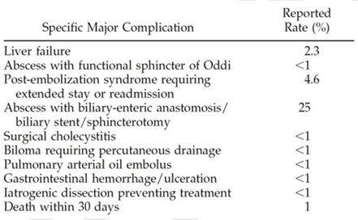

This could be used as a guide for some of the complications that might occur during Y90- microspheres administration. The number of procedures relating to these complications in Australia may increase with the listing of Y90-microspheres on the MBS. Note though that expert advice obtained during development of the DAP highlighted that radioembolisation with microspheres is thought to be superior to the TACE procedure in terms of patient burden; patients treated with Y90- microspheres are likely to have reduced hospital stay and potentially fewer AEs and associated complications.

The applicant response to the draft DAP asserts that it is not useful to examine complication rates for TACE to identify the complications that may occur with radioembolisation. Sirtology notes that there are numerous published scientific articles from extensive clinical experience (including randomised trials) that describe the complication rate and adverse event profile for patients treated with resin based yttrium-90 containing microspheres such as SIR-Spheres and Y90-microspheres.

In conducting an economic evaluation of Y90-microspheres it would be appropriate to incorporate costing information for managing AEs and complications such as analgesic costs and the relevant AR- DRG costs for some of the more serious events. This would be combined with data or assumptions on the quality of life impact that these sorts of AEs would have on patients.

Primary Liver Cancer

Y90-microspheres are intended to be used in combination with chemotherapy or as a treatment option for chemorefractory disease. Within chemotherapies doxorubicin may be used; doxorubicin is listed on the PBS with item numbers 4361M and 7229L. Doxorubicin is the most commonly used agent for systemic therapy for HCC; however, it does not appreciably affect survival and responses are rare (Guidelines Brown 2009).

The clinical algorithms developed in 2005 by the MSAC advisory panel (featured later in the DAP) for the indication of primary liver cancer do not explicitly contain systemic chemotherapy as a treatment option. This is possibly due to the perceived lack of efficacy of systemic chemotherapy in these patients. Expert advice obtained during the development of the DAP that reiterated that systemic chemotherapy has limited efficacy in primary liver cancer or hepatocellular carcinoma (HCC) and is rarely used.

The applicant responds to the draft DAP that Sirtology does not recommend the use of doxorubicin in combination with Y90-microspheres.

Systemic chemotherapy treatments that are associated or co-administered with Y90-microspheres are discussed below under the subheading of metastatic liver cancer.

Sorafenib, a multitarget tyrosine kinase inhibitor, was PBS listed in July 2008 for the treatment of advanced hepatocellular carcinoma in patients with unresectable disease. The PBS item number is
9380Q.

It is likely that the use of sorafenib will be affected in some way by the listing of Y90-microspheres for this patient group. Some patients may be administered Y90-microspheres instead of sorafenib treatment and within this group there may be patients who achieve tumour down-staging and access surgery without receiving sorafenib treatment. This depends largely on clinical practice in Australia; however, sorafenib may be used in preference to Y90-microspheres, in which case the number of administrations of sorafenib would be relatively unaffected. Sorafenib is restricted to use within this indication and is not available for use in patients with liver metastases arising secondary to colorectal cancer.

131I-Lipidiol combines a substance derived from poppy seed oil and radioactive 131Iodine. It has been used as a targeted therapy in Australia in the relevant patient group. Following administration, patients are kept in a lead-lined single room for around 5–7 days until their radiation levels are acceptable. During hospitalisation, tolerance is estimated clinically and from liver function tests on day

one and before discharge. In addition, a planar scintiscan of the liver and thorax are performed 24 hours after administration and before discharge. Repeat treatments are given depending on patient progress. The 2005 review of SIR-Spheres found that an appropriate comparator for SIR-Spheres was
131I-Lipidiol. The Advisory Panel stated that this is used in clinical practice as a treatment for HCC, and
its use is supported at least to some extent by existing evidence demonstrating efficacy. It appears that 131I-Lipidiol is not PBS or MBS listed and expert advice indicated that 131I-Lipidiol is now rarely used in Australia largely due to the requirement of patient isolation and the risk of radiation exposure to staff.

Metastatic Liver Cancer

Y90-microspheres will be most commonly used in combination with systemic chemotherapy for patients with liver metastases that are secondary to colorectal cancer (rather than primary liver cancer). It is also possible that systemic chemotherapy will be used without SIRT as a separate treatment option.

The chemotherapy option identified in the MBS interim listing of SIR-Spheres is 5-fluorouracil (5FU). Fluorouracil is PBS reimbursed as injection or infusion with item codes 4394G, 4431F, 4234R, and
7239B. The interim MBS descriptors also identify leucovorin as a treatment used in combination with SIR-Spheres. Leucovorin is the brand name for folinic acid and is available on the PBS as a tablet or injection with item codes 2308L, 8740B, 8812T, and 9041W.

Expert advice sourced from the advisory panel during the 2005 MSAC review of SIR-Spheres indicated that 5FU plus leucovorin alone is no longer used in current clinical practice. Patients are commonly treated with the following alternative regimens in Australia:

• FOLFOX6 regimen (oxaliplatin, leucovorin, 5FU): Oxaliplatin (85–100 mg/m2) as a 2-hour infusion day 1; leucovorin (400 mg/m2) as a 2-hour infusion day 1; followed by a loading dose of 5FU (400 mg/m2) IV bolus on day 1, then 5FU (2400–3000 mg/m2) via ambulatory pump over 46 hours every 2 weeks.

• FOLFIRI regimen (leucovorin, 5FU, irinotecan): Irinotecan (180 mg/m2) as a 2-hour infusion day 1; leucovorin (400 mg/m2) as a 2-hour infusion day 1; followed by a loading dose of 5FU (400 mg/m2) IV bolus on day 1, then 5FU (2400–3000 mg/m2) via ambulatory pump over 46 hours every 2 weeks.
Expert advice indicates that these chemotherapy regimens are still relevant and in clinical practice in
Australia.

Oxaliplatin is listed on the PBS with item numbers 4542C 7253R and the authority required indication of metastatic colorectal cancer in a patient with a WHO performance status of 2 or less, to be used in combination with 5-fluorouracil and folinic acid.

Irinotecan hydrochloride trihydrate is available on the PBS (items 4451G and 7249M) for metastatic colorectal cancer in patients with a WHO performance status of 2 or less. This is the same as oxaliplatin above and represents another intervention that may be coadministered with Y90- microspheres.

It is uncertain whether the reimbursement of Y90-microspheres will affect the use of these PBS listed items. There may be a relatively small increase in their use if Y90-microspheres confer a benefit in overall survival.

An issue that will affect the economic evaluation is the impact on quality of life (or the health states attained by patients) assumed to be attributable to Y90-microspheres with and without systemic chemotherapy. It is possible that patients who are administered Y90-microspheres and in whom chemotherapy is not an option will achieve health states with reduced quality of life compared with patients in whom chemotherapy is used in combination with Y90-microspheres. Equally the short-term burden of chemotherapy as a treatment may need to be considered when estimating patient quality of life in an economic evaluation.

The 2005 MSAC review of SIR-Spheres considered treatments that were current practice at the time but since that time there have been a number of other medicines and procedures developed, which may be used in this patient group.

Cisplatin is listed on the PBS with item numbers 4319H and 7224F as a chemotherapy option for use in public and private hospitals.

Cetuximab is another PBS listed chemotherapy option for patients with a WHO performance status of
2 or less and with K-RAS wild type metastatic colorectal cancer after failure of first-line chemotherapy. It’s available for initial and continuing treatment as monotherapy or in combination with an irinotecan based therapy. The relevant item numbers include 4436L, 4731B, 7242E, and 7273T and have a note attached specifying that cetuximab is not for use in combination with oxaliplatin or bevacizumab based regimens.

Capecitabine is a chemotherapy agent reimbursed on the PBS for the indication of advanced or metastatic colorectal cancer (among others). Capecitabine is available as an oral tablet, which is converted to 5-fluorouracil in the tumour. The item numbers are 8361C and 8362D.

The aim of hepatic arterial chemotherapy (HAC) is to treat the microscopic disease directly (rather than using a systemic approach which may not be as effective). HAC is delivered via an implantable port and these systems require laparotomy for catheter placement and construction of a subcutaneous pocket for the pump. HAC allows ambulatory treatment and avoids repetitive arterial access. Commonly used chemotherapy agents in HAC include 5FU, cisplatin, doxorubicin and potentially oxaliplatin, irinotecan, cetuximab.

Bevacizumab is a humanised monoclonal antibody that inhibits vascular endothelial growth factor A (VEGF-A). It is listed on the PBS for initial and continuing treatment, in combination with first line chemotherapy, of a patient with previously untreated metastatic colorectal cancer with a WHO

performance status of 0 or 1. This indicates that if bevacizumab is to be used it will be used early in the clinical algorithm for these patients with liver cancer secondary to colorectal cancer. Continuing treatment with bevacizumab is only available if the patient remains on first-line treatment with bevacizumab and does not have progressive disease; because of this it is unlikely to be coadministered with Y90-microspheres, which are generally positioned later in the algorithm. Item numbers for bevacizumab are 4400N and 7243F.

The applicant responds to the draft DAP that an ongoing randomised study of Yttrium 90 resin microspheres as first line treatment with oxaliplatin and bevacuzimab will determine safety of bevacuzimab in combination with Y90-microspheres.

Listing proposed and options for MSAC consideration

Proposed MBS listing

The application requests that the MSAC consider a proposed listing for Y90-microspheres identical to the SIR-Spheres interim items 35404 and 35406 currently reimbursed. However, given that the name SIR-Spheres cannot be taken to be generic, the name used in the proposed MBS item should be altered. Tables 12 and 13 below set out the proposed MBS listing as presented in the information request documents. PASC agreed with a proposal in the applicant’s response to the Consultation DAP that it would be appropriate for the term “resin-based Y90 microspheres” to be used in place of the word “microspheres” in the item descriptions presented in Table 12 and Table 13 to differentiate resin-based Y-90 microspheres from other, unproven microsphere formulations.

Table 12: Proposed MBS item descriptor for Y90-microspheres dosimetry, handling and injection
Category 3 – THERAPEUTIC PROCEDURES

MBS XXXX

Dosimetry, handling and injection of microspheres for selective internal radiation therapy of hepatic metastases which are secondary to colorectal cancer and are not suitable for resection or ablation, used in combination with systemic chemotherapy using 5-fluorouracil (5FU) and leucovorin, not being a service to which item 35317, 35319, 35320 or 35321 applies

The procedure must be performed by a specialist or consultant physician recognised in the specialties of nuclear medicine or radiation oncology on an admitted patient in a hospital. To be claimed once in the patient's lifetime only.

Fee: $333.50

The key difference between Table 12 above and the current MBS item descriptor for item 35404 is the fee: currently the fee listed on the MBS is $340.15 for item 35404. Other differences include the absence of the referral to the Multiple Services Rule (T8.2), and the explanatory note discussing the interim arrangement and the upcoming MSAC review of SIRT with SIR-Spheres and its evidence.

Table 13: Proposed MBS item descriptor for Y90-microspheres trans-femoral catheterisation
Category 3 – THERAPEUTIC PROCEDURES

MBS XXXX

Trans-femoral catheterisation of the hepatic artery to administer microspheres to embolise the microvasculature of hepatic metastases which are secondary to colorectal cancer and are not suitable for resection or ablation, for selective internal radiation therapy used in combination with systemic chemotherapy using 5-fluorouracil (5FU) and leucovorin, not being a service to which item 35317, 35319, 35320 or 35321 applies

excluding associated radiological services or preparation, and excluding aftercare
(Anaes.) (Assist.) Fee: $782.50

The key difference between Table 13 above and the current MBS item descriptor for item 35406 is the fee: currently the fee listed on the MBS is $798.15 for item 35406. Other differences again include the absence of the referral to the Multiple Services Rule (T8.2), and the explanatory note discussing the interim arrangement and the upcoming MSAC review of SIRT with SIR-Spheres and its evidence.

The application omits an MBS listing corresponding with the current item 35408 for catheterisation of the hepatic artery via a permanently implanted hepatic artery port to administer Y90-microspheres. It is unclear why this is not proposed.

Both Table 12 and Table 13 presented above and in the application specify hepatic metastases secondary to colorectal cancer. This is different to the indication for the intervention proposed elsewhere in the information request documents, which refers to hepatic primary and secondary cancers. The information provided in the application for the medical condition discusses both primary liver cancer (of which the majority is hepatocellular carcinoma (HCC)) and metastatic liver cancer secondary to a variety of other cancers. The requested listing may be narrower than intended as primary hepatic metastases and hepatic metastases secondary to forms of cancer other than colorectal do not appear to be included.

The PASC noted that the proposed item descriptors are narrower than the proposed population, as they only reference patients with cancer secondary to colorectal cancer, while the proposed population includes patients with primary or secondary cancer. PASC noted the proposal to extend the metastatic disease indication to include non-colorectal liver metastases. PASC considered that it would be appropriate for an application to request MBS items that covered the broader population however the TGA indications should support such an extension and evidence demonstrating the comparative effectiveness and safety of SIRT in patients with non-colorectal liver metastases versus the appropriate comparator would need to be presented to support such an extension of the current listing of SIRT.

There is no explicit restriction on the number of administrations per patient for the item proposed in Table 13 unlike Table 12, which includes the wording, ‘to be claimed once in the patient’s lifetime only.’ The application suggests that a repeat administration may be appropriate in certain patients who respond well.

The cover letter provided by the applicant along with the information request documents states that it is Sirtology’s intention to provide its resin-based Y90-microspheres as a generic product at pricing significantly less than the competitor SIR-Spheres.

The application does not elaborate on this statement although the price proposed in the MBS item descriptors is less than the current amount reimbursed for SIR-Spheres. The incremental saving between SIR-Spheres and Y90-microspheres is relatively small.

Patient population

Y90-microspheres treatment is used in patients with non-operable liver cancer either in combination with chemotherapy or as a chemo-refractory treatment option. The application states that patients with liver cancer will inevitably be investigated to determine the extent of disease within the liver and the presence of cancer in extra-hepatic sites. Only patients with cancer that is limited to the liver (liver only disease) or where the liver is the dominant site of disease (liver dominant disease) will ever qualify for treatment with Y90-microspheres.

The statement above that only those patients with liver dominant disease will qualify for treatment with Y90-microspheres may be inconsistent. It does not appear to align with the proposed MBS listing (patients with liver cancer secondary to colorectal cancer) or the indication of primary or secondary liver cancer proposed in other parts of the application.

The criteria for inclusion/exclusion below define the patient populations that are likely to benefit from
SIRT with Y90-microspheres have been articulated by Wang et al., 2010.

The clinical parameters for many of the selection criteria listed below may already be known for an individual patient as the patient will have undertaken a number of tests (for example blood tests) as part of their ongoing cancer management. Other tests or relevant patient history is required to be completed as part of the patient assessment.

Acceptable presentations and history include:

• Life expectancy >3 months,
• Liver-only or liver dominant disease,
• Tumour(s) not amenable to thermal ablation or surgical resection,
• Child-Pugh status of A, or at most early B in cirrhotic patients,
• Serum alinine aminotransferase (ALT) or aspartate aminotransferase (AST) ≤ 5 times upper limit of normal (ULN),
• Serum bilirubin ≤ 35 umol/L,
• Serum albumin ≤30 g/L,
• Caution if prothrombin time extended,
• Partial lobar invasion of the portal vein,
• Minimal comorbidities,
• Eastern Cooperative Oncology Group (ECOG) score 0-2 or Karnofsky index ≥ 60%.

Contraindications for Y90-microspheres:

• Patients with life expectancy < 3 months ,
• Ascites or clinical liver failure,
• Child-Pugh status late B or C,
• Prior external beam radiation to the liver,
• Prior extensive liver resection or any bilio-enteric anastomosis,
• Extensive portal vein thrombosis,
• Anticipated lung exposure to Yttrium-90 radiation greater than 30 Gy based on pre-procedural
Technetium 99m MAA scan,
• Anticipated reflux of microspheres into arteries supplying the stomach, pancreas or duodenum, based on pre-procedural angiography,
• Albumin < 90% ULN,
• Bilirubin > 1.5 ULN,
• Extensive extrahepatic disease,
• Technetium-99m MAA liver shunt fraction >20%,
• Ascites or clinical liver failure
The inclusion and exclusion criteria listed in the application and reproduced above are relatively complex and incorporate specific clinical markers and certain thresholds on instruments that measure the impact of disease (for example the ECOG and Karnofsky indices). Some criteria are ambiguous or open to interpretation (for example ‘extensive extrahepatic disease’). If the criteria are to be followed there will be a need for substantial testing (some of which may already be conducted in these patients as noted in the application) entailing time and costs for medical specialists. The extra cost of assessing the clinical markers must be included in an economic evaluation of Y90-microspheres.

For reference, Figure 2 displays the Child-Pugh scoring system described in the inclusion and exclusion criteria. Of note some of the clinical markers contribute to the Child-Pugh score.

Figure 2: Child-Pugh scoring system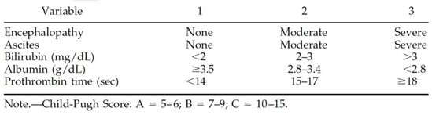

There is currently no registered or approved indication as the TGA application has not yet been submitted.

Clinical place for proposed intervention

In the information request documents the application proposes that Y90-microspheres be used in patients with non-resectable, non-ablatable primary and secondary liver cancers. However, in the proposed MBS item descriptors above a listing identical to that of the interim reimbursed SIR-Spheres is requested, that is, for patients with non-resectable, non-ablatable hepatic metastases secondary to colorectal cancer. Because these two descriptions of the requested indication vary substantially in terms of the clinical management they will be treated separately under two subheadings below.

Primary Liver Cancer
This subheading focuses on the clinical management of patients with hepatocellular carcinoma (HCC). During the 2005 MSAC review of the use of SIR-Spheres, a flow chart was developed to represent the
(then current) clinical management of patients with HCC with the inclusion of SIR-Spheres as a treatment option. This diagram is reproduced below (with an update) and Y90-microspheres would most likely fit in at the same point as SIR-Spheres. Note that the flow diagram includes health outcomes of overall and progression-free survival among others; these outcomes were decided on during the 2005 review in conjunction with the Advisory Panel and are not the outcomes submitted by the current applicant for Y90-microspheres.

Figure 3 sets out the updated clinical management algorithm with the addition of SIR-Spheres for patients with non-resectable hepatocellular carcinoma.

Figure 3: Clinical management of patients with non-resectable hepatocellular carcinoma

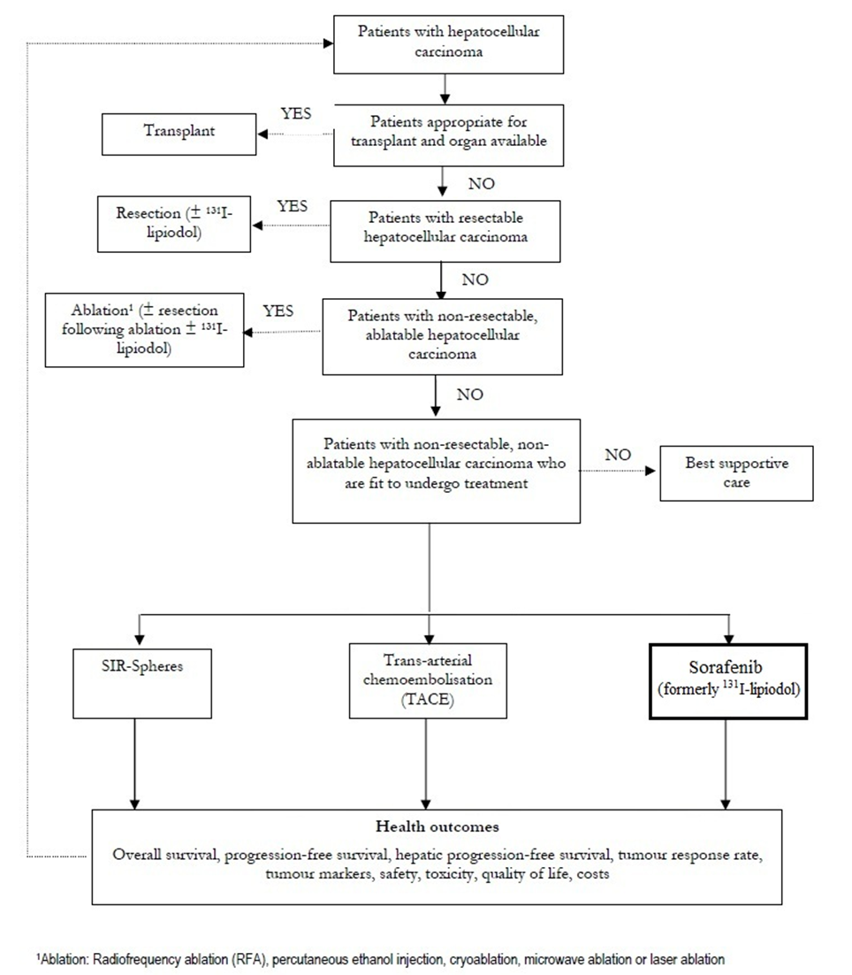

The diagram above shows patients with HCC being investigated for transplant, then resection, then ablation. Those remaining patients with non-resectable, non-ablatable HCC have the choice between three options: radioembolisation with microspheres, transcatheter arterial chemoembolisation (TACE) and sorafenib. After a decision is made amongst the three options and a treatment is administered the diagram appears to show that patients may return to the beginning of the algorithm and subsequently gain access to the other remaining treatment options or repeat the initial option.
In the currently proposed MBS item descriptors for Y90-microspheres, which are based on the interim descriptors for SIR-Spheres, there is mixed wording regarding repeats. Item 35404 states that it is to be claimed once per patient lifetime, while item 35406 does not set a limit on repeats. The ability for patients to repeat treatment with any or all of the options outlined has potential impacts on the economic evaluation of radioembolisation.

In the original diagram in 2005 the option of sorafenib (in the bold black box above) was not available; instead there existed the possibility of administering 131I-lipiodol. According to expert advice this procedure is now very uncommon in Australia and so the diagram has been adjusted during DAP development to better represent the current management algorithm. The diagram in Figure 3 now concurs (for the management of non-operable HCC) with the algorithm presented in Bruix et al.,
2011.

Note that 131I-lipiodol features in the above diagram as a potential treatment following resection or following ablation. It is uncertain what treatment will substitute for this in current clinical practice although the patient group relevant to the present DAP is those with non-resectable and non- ablatable disease.

Treatment with systemic chemotherapy is not presented in Figure 3. Expert advice obtained stated that systemic chemotherapy is not commonly employed as active treatment of patients with non- operable HCC due to its limited efficacy; however, it may be used as a form of palliative care. Brown et al., 2009 states that doxorubicin is the most commonly described agent for systemic therapy for HCC; however, it does not appreciably affect survival and responses are rare.

With few systemic treatment options, there has been a growing reliance on the use of individualized liver-directed treatments such as transcatheter arterial embolisation (TAE), transcatheter arterial chemoembolisation (TACE), and radioembolisation for patients with unresectable disease (Sangro et al., 2011).

TACE represents an option with evidence for efficacy in patients with early to intermediate hepatocellular carcinoma and TACE has become the standard of care for many patients that cannot be resected or ablated. However, radioembolisation can be used in a broader group of patients than TACE, including those with more advanced disease, with or without portal vein thrombosis (Sangro et al., 2011). According to Liapi and Geschwind, 2011 there is also the possibility that TACE could be used in combination with sorafenib or with bevacizumab.

Bevacizumab is currently not available on the PBS for use in patients with primary liver cancer but the option of combining sorafenib with TACE may be needed in the algorithm.

As discussed earlier in the DAP, transcatheter arterial embolisation (TAE) is related to TACE but does not involve chemotherapy agents. The application states that Y90-microspheres may be used in patients with chemotherapy refractory disease. In these patients TAE may be a possible option but it does not feature in Figure 3. As noted previously, PASC agreed with the sponsor’s claim (in their response to the Consultation DAP) that TAE is a procedure that is rarely used and therefore does not need to be included in the treatment algorithm or as a relevant comparator.

Hepatic arterial chemotherapy, like systemic chemotherapy does not appear in the algorithm for management of HCC.

The normal order of the delivery of therapies in Figure 3 needs to be determined to inform the choice of comparator for Y90-microspheres and radioembolisation in general. This will also inform the construction of a decision analytic model for economic evaluation if necessary.

Colorectal liver metastases

This subheading discusses the clinical management of patients with hepatic metastases secondary to colorectal cancer.

The application states that in clinical practice in Australia, most patients with non-resectable CLM are first offered treatment with systemic chemotherapy either with or without the addition of biologic agents such as anti-angiogenesis agents. Several different cocktails of systemic chemotherapy may be used as the prior one fails. SIRT using microspheres is usually offered as a treatment option for patients who have failed all or most chemotherapy options; however, the application states that Y90- microspheres treatment is positioned as concurrent in combination with chemotherapy or as a treatment option for chemo-refractory disease.

Systemic chemotherapy has limited efficacy in primary liver cancer, or HCC, and is less commonly used according to expert opinion and clinical literature and so it is assumed that the application is here referring to treatment of patients with liver cancer secondary to colorectal cancer.

The treatment algorithm with and without the addition of Y90-microspheres to the MBS is not presented in diagrammatic form in the information request documents. The application presents a list representing the typical clinical pathway for SIRT:

1. Diagnosis of advanced non-resectable CLM

2. Treatment with 1st line chemotherapy/biologic therapy

3. Treatment with 2nd line chemotherapy

4. SIRT with resin-based Y90-microspheres

5. After SIRT, possible surgical resection → possible long term survival or cure

6. If not cured, then death

The usefulness of this list is limited as it lacks detail on treatments and does not make clear what the change in the current clinical management algorithm would be if Y90-microspheres were reimbursed on the MBS. The appropriate comparator to Y90-microspheres also cannot be determined from the list although it can be inferred that radioembolisation may commonly be used later in the clinical management algorithm. Inclusion of a diagram of the clinical management algorithm with and without the addition of Y90-microspheres as a treatment option would be most appropriate.

During the 2005 MSAC review of the use of SIR-Spheres, a flow chart was developed to represent the (then current) clinical management of patients with hepatic metastases secondary to colorectal cancer with the inclusion of SIR-Spheres as a treatment option. This diagram is reproduced below and Y90- microspheres would most likely fit in at the same point as SIR-Spheres. Once again the flow diagram incorporates health outcomes from the 2005 MSAC review; these are not outcomes that have been submitted as part of the current application for MBS reimbursement of Y90-microspheres.

Figure 4 depicts the clinical management algorithm with the addition of SIR-Spheres for patients with hepatic metastases secondary to colorectal cancer.

Figure 4: Clinical management of hepatic metastases secondary to colorectal cancer

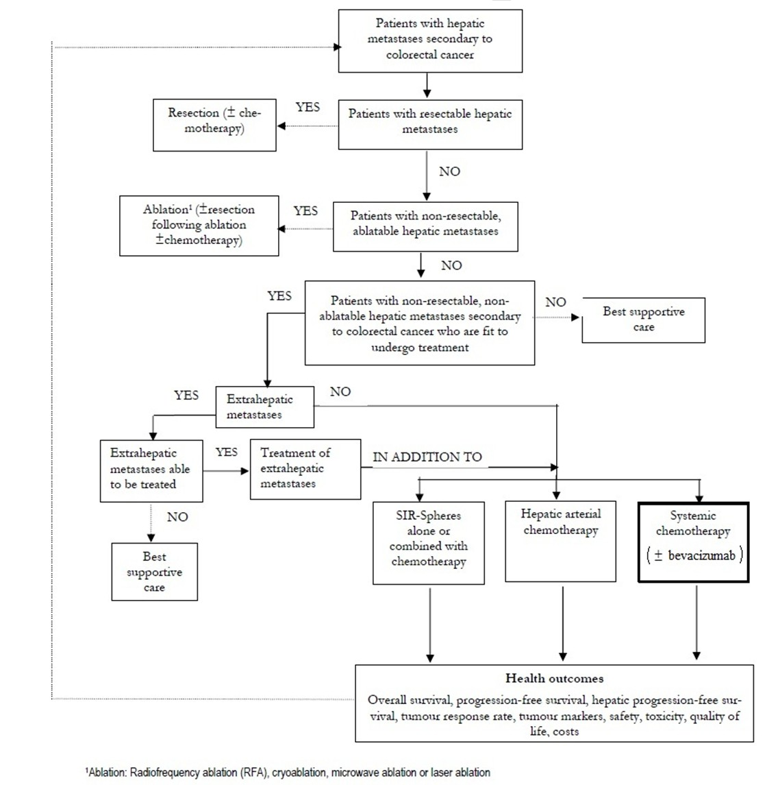

Figure 4 above describes the Australian clinical management algorithm circa 2005 with the addition of
SIR-Spheres for patients with hepatic metastases secondary to colorectal cancer. Once it is

determined that the metastases are non-resectable and non-ablatable the patient is checked for extra- hepatic metastases. The diagram does not specify the scan used to determine the existence of tumours outside of the liver but the economic evaluation conducted as part of the report notes that a CT scan would be undertaken. If extrahepatic metastases are identified but not able to be treated then the patient will not have the option of SIR-Spheres or Y90-microspheres, which concurs to a degree with the patient exclusion criteria presented in the application (that of exclusion due to extensive extrahepatic disease). The diagram does not specify the therapies for extrahepatic metastases that are deemed treatable but notes that these therapies will be administered in addition to treatment for the hepatic metastases. For patients without extrahepatic disease three options are available: SIR-Spheres, systemic chemotherapy, and hepatic arterial chemotherapy. After a decision is made amongst the three options and a treatment is administered the diagram appears to show that patients may return to the beginning of the algorithm and subsequently gain access to the other remaining treatment options or repeat the initial option (like with the algorithm for HCC earlier).

This is an aspect that would need to be considered before listing Y90-microspheres on the MBS. Expert advice indicates that repeat treatments with SIR-Spheres or Y90-microspheres may have some appeal as there is preliminary evidence to support multiple uses in obtaining down-staging of liver tumours to the point where surgical resection or ablation is possible.

In the original algorithm in 2005 the option of bevacizumab (now added in the bold black box in the diagram) was not available. According to the PBS restriction on bevacizumab it is not to be used as monotherapy. It is for initial or continuing PBS-subsidised treatment, in combination with first-line chemotherapy for patients with metastatic colorectal cancer.

Bevacizumab is restricted for use early in the clinical algorithm. It may be used before SIRT with microspheres. Systemic chemotherapy may be used without bevacizumab at any point in the treatment of the patient.

Expert advice obtained during DAP development indicated that transcatheter arterial chemoembolisation (TACE) may be a valid treatment option in these patients. TACE does not feature in the algorithm above although expert opinion was that radioembolisation may substitute directly for TACE. Additionally there may be a clinical preference for SIRT with microspheres because (as discussed earlier in the DAP) patients are likely to have reduced hospital stay and potentially fewer AEs and associated complications with radioembolisation compared with TACE. This may be the reason that TACE does not appear in Figure 4 (SIR-Spheres may directly substitute for TACE).

Hepatic arterial chemotherapy (HAC) is delivered via an implanted port and has no embolisation component. As mentioned earlier, commonly used chemotherapy agents in HAC include 5FU, cisplatin, doxorubicin and others, some of which have previously been mentioned earlier in the DAP.

Importantly the usual order of interventions in Figure 4 must be determined with particular attention paid to systemic and hepatic arterial chemotherapy in combination with Y90-microspheres.

It is asserted in the application that SIRT is most effective in patients minimally treated with prior chemotherapy. The continual accumulation of new data in the international scientific literature

appears to be influencing some treating physicians to position SIRT as an early, rather than late, treatment option. Some (the application suggests 5-10%) patients with liver only disease who are not candidates for surgical resection may be effectively treated with SIRT to the point where the cancer is sufficiently down-staged to where surgical resection then becomes possible. This has the potential to result in long term survival or cure. The application notes that clinical trials are currently underway and will further define the use of resin based Y90-microspheres in the treatment of patients with advanced liver cancer.

If radioembolisation with Y90-microspheres is restricted to a late position in practice (after failure of all or most chemotherapy options) the potential for down-staging of cancers to where surgery becomes an option may be reduced. However, it is uncertain how often down-staging occurs and whether this has an effect on overall survival. Further, without clinical efficacy information the cost- effectiveness of early versus late positioning is uncertain.

The PASC considered that the clinical treatment algorithms appear appropriate as presented and capture the correct treatment options for both of the indications. However, the subcommittee welcomes further comment on the algorithms from stakeholders.

Comparator

The application nominates SIR-Spheres (interim MBS codes 35404 and 35406) as the appropriate comparator. Further the application asserts that the service of Y90-microspheres will be used in exactly the same clinical pathway as the existing SIR-Spheres product. It is claimed that there is no other relevant comparator for Y90-microspheres.

The MBS item descriptors for 35404 and 35406 are reproduced earlier in the DAP (Tables 1 and 2) within the discussion of current arrangements for public reimbursement. The proposed MBS listing detail for Y90-microspheres covered above is identical to the MBS item descriptors for SIR-Spheres.

The nomination of SIR-Spheres as the sole comparator is not appropriate given that they are listed on the MBS under interim-funding and it cannot be assumed that SIR-Spheres will remain interim-funded. It is appropriate to also include the items that were used as comparators for SIR-Spheres in the 2005
MSAC review as well as items that have since entered the clinical management algorithm for these
patients. For hepatocellular carcinoma the original comparators in the 2005 MSAC review for SIR- Spheres were TACE and 131I-lipiodol. The option of 131I-lipiodol is no longer appropriate to use as a comparator in Australia. Rather there is now the possibility of treatment with sorafenib in these patients. Additionally the combination of TACE and sorafenib may be used in some patients.

For metastatic colorectal cancer tumours that have spread to the liver the comparators would be systemic chemotherapy (FOLFOX6 regimen (oxaliplatin, leucovorin, 5FU) or FOLFIRI regimen (leucovorin, 5FU, irinotecan)) and hepatic arterial chemotherapy (HAC) (5FU, doxorubicin, cisplatin, potentially oxaliplatin, irinotecan, cetuximab). Clinical expert advice has suggested that transcatheter arterial chemoembolisation (TACE) may be an appropriate comparator.

PASC determined that the primary comparator in both indications requested should be the items identified in the DAP, including transcatheter arterial chemoembolisation (TACE), hepatic arterial chemotherapy (HAC), and targeted sorafenib therapy as well as systemic chemotherapy, The interim- listed SIR-Spheres could act as the secondary comparator to provide further context to the decision whether to formally reimburse Y90-microspheres on the MBS.

The PASC noted that treatment with bevacizumab should be included in the range of potential comparators for the indication of hepatic metastases arising secondary to colorectal cancer.

Clinical claim

The clinical claim made in the application is that Y90-microspheres will produce a similar therapeutic effect in patients compared with the interim listed SIR-Spheres, but superior safety outcomes for personnel associated with its handling and administration. The reasoning for this is as follows:

• The Y90-microspheres device is provided as a patient-specific dose and therefore the requirement for sub-dispensing by the treating institution, as is required by the SIR-Spheres product, is removed. This results in less handling of the device and less radiation exposure to staff.

• As all the Y90-microspheres supplied as a patient-specific dose will be used and there will not be any residual radiation needing to be disposed of, this will relieve the need to handle ‘waste’ left over yttrium-90, thus further adding to safety.
This assertion of similar therapeutic effect (efficacy and safety) in patients is not further justified in the application. It is uncertain whether the delivery of a patient-specific dose will translate to fewer safety issues for staff handling the radioactive product and whether this in turn would translate to a measurable clinical or cost effect. In addition there may be dose variations due to the degree of lung shunting, potentially limiting the claimed advantages. No evidence is provided in support of this claim of safety in the application. Without evidence it is likely that there would be no difference between Y90-microspheres and SIR-Spheres in efficacy and safety, which would necessitate cost-minimisation analysis.

The PASC minuted that this claimed safety advantage for Y90-microspheres (versus SIR-Spheres) may not have a significant clinical and cost impact. Any differences claimed between the two sphere brands such as with respect to safety will need to be supported by evidence particularly if there are resource implications.

No clinical claim is made in the application for Y90-microspheres versus the other treatments identified as potential comparators used in the same patient groups. If Y90-microspheres are not cost- minimised against SIR-Spheres then there will be a need for cost-effectiveness analysis against the most appropriate comparator (as identified by PASC). This will entail a clinical claim on efficacy and safety based on the evidence available.

Proposed structure of economic evaluation (decision-analytic)

Table 14 below summarises the PICO updated for comparisons with current clinical practice for each of the indications sought.

Table 14: Summary of extended PICO to define the question for public funding that assessment will investigate

Population | Intervention | Comparator(s) | Outcomes to be assessed | Health resources
Patients with primary liver cancer: hepatocellular carcinoma | Treatment with Y90- microspheres | TACE Sorafenib  TACE + sorafenib | To be determined | To be determined
Patients with secondary liver cancer: hepatic metastases arising secondary to colorectal cancer | Treatment with Y90- microspheres | Systemic chemotherapy  Hepatic arterial chemotherapy  TACE | To be determined | To be determined

The extended PICO is presented in the application on the premise that Y90-microspheres will be compared against SIR-Spheres. The health resources column was not completed in the application likely due to the claim that Y90-microspheres will be identical in resource use to the proposed comparator SIR-Spheres. The “outcomes to be assessed” column was presented as “outcome claims” with the items, ‘comparable therapeutic effect,’ ‘greater user safety,’ and ‘greater cost effectiveness.’

These outcome claims need to be updated for the comparison with current clinical practice and specific clinical outcomes must be identified. This is discussed further below under the subheading of “clinical outcomes.”

Given that SIR-Spheres are interim-funded and the duration of that funding is not known, as indicated above, the appropriate comparators are systematic chemotherapy or HAC for metastatic colorectal cancer tumours that have spread to the liver, TACE, and for patients with hepatocellular carcinoma TACE. Therefore, under the assumption that the sponsor has evidence in support of Y90-microspheres versus these comparators, a cost-effectiveness analysis of Y90-microspheres compared with current clinical practice will be required.

The exact structure of the decision analytic will depend, to some degree, on the clinical management algorithm, which was not clearly defined by the sponsor and will also require clinical expert advice. The following subheadings have been developed after submission of the draft DAP but before the PASC meeting. The diagrams of the proposed model structures have been presented to PASC but the explanatory text below has not been considered by the subcommittee.

Primary Liver Cancer

An example model structure representing the treatment of patients with hepatocellular carcinoma (HCC), has been created during development of the DAP. This model structure aims to compare the treatment of patients with HCC in Australia in a scenario where there is MBS reimbursement of Y90- microspheres compared with current standard of care by way of cost-utility analysis (CUA). The structure has been created using the TreeAge Pro 2011 modelling software.

Figure U1 below illustrates the potential model structure for an economic evaluation of treatment of
HCC with Y90-microspheres compared with current practice.

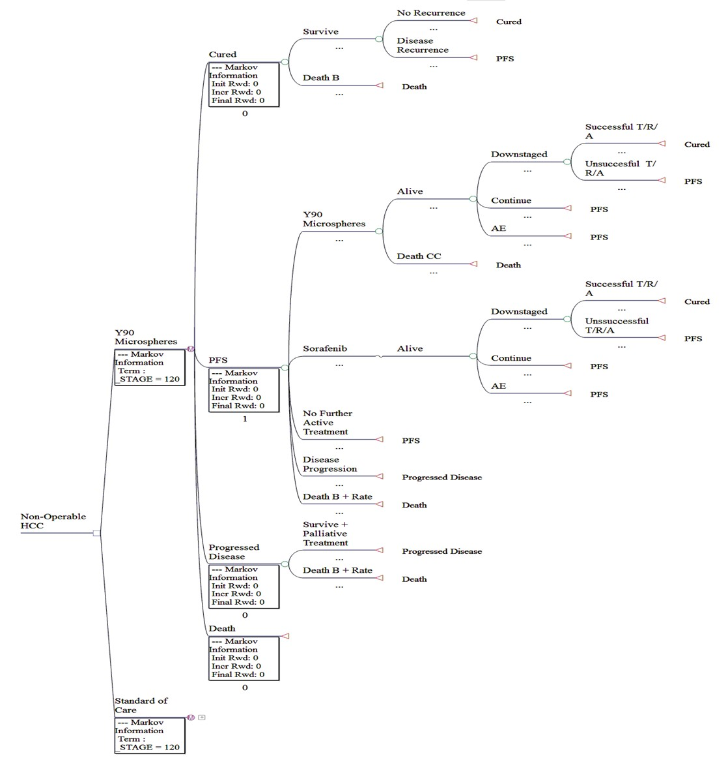

Figure U1: Potential model structure for Y90-microspheres in HCC

The Markov model structure presented in the diagram above is simplified and entails a number of assumptions and requirements for it to be a useful representation of reality. It currently contains no probability data informing transitions and no outcomes (costs or utilities). A cycle length appropriate for the treatment durations would be set and the time horizon should cover patient lifetimes.

The model is set up as a decision between two alternate scenarios represented by Markov trees. In the first Y90-microspheres are reimbursed on the MBS and in the second Y90-microspheres are not available. The primary comparator for radioembolisation in this model is transcatheter arterial chemoembolisation (TACE).

In both Markov trees there are four health states: “Cured,” “Progression Free Survival (PFS),” “Progressed Disease,” and “Death.” Patients with non-resectable, non-ablatable HCC ineligible for transplant (or transplant organ not available) entering either tree begin in PFS with the option of treatments. In the scenario with funding of Y90-microspheres radioembolisation and sorafenib are the active treatments. In the alternate scenario TACE is available also with sorafenib. A simplifying assumption is that Y90-microspheres directly replace TACE in all patients in the first scenario. The effect of this is that TACE is not a treatment option in the first scenario. It is uncertain whether or not TACE would be used in practice after a patient has received radioembolisation.

The intention is that patients initially attempt either radioembolisation or TACE depending on the scenario. The model then captures differences in the rates of complications, adverse events (AEs), tumours down-staged, overall and progression free survival. Costs and payoffs representing these features can be incorporated at the nodes or transition points at which they occur (AEs and complications may need to be weighted by occurrence and impact and assigned as a weighted mean value).

The application states that there is now plentiful data that some patients with liver only disease who are not candidates for surgical resection may be effectively treated with SIRT to the point where the cancer is sufficiently down-staged to where surgical resection then becomes possible and results in long term survival or cure. Transition from the “PFS” health state to the “Cured” health state is possible via the active treatments of either radioembolisation or TACE, and sorafenib producing a tumour down-staging effect. In each case, however, the transition depends on an estimate of the numbers of people who are subsequently successfully treated with transplant or resection or ablation (T/R/A). Transition from “Cured” back to “PFS” is also possible. The estimation of the relative effect on down-staging of disease and then the likelihood of disease recurrence are expected to be influential variables in this model as the “Cured” health state allows patients to achieve the higher quality of life and incur fewer costs. Where possible these transition probabilities must be informed by evidence and properly sensitivity tested.

Once the patient has received the primary treatment in either scenario there is the option of accessing sorafenib for a proportion of patients. Sorafenib, like Y90-microspheres and TACE, has similar options for triggering a transition to “Cured” and for incurring AEs although the attached probabilities based on clinical evidence will be different. The costs and quality of life impact may be different also to better represent the outcomes with sorafenib.

In both scenarios the model would limit the number of active treatments administered and the majority of patients would continue cycling through the “PFS” health state incurring the costs associated with monitoring and maintenance treatment. The rates of transition from “PFS” to “Progressed Disease” would vary across scenarios to reflect the relative difference observed between radioembolisation and TACE in the clinical literature and in the patient group.

Once the patient transitions to “Progressed Disease” there is no option of returning; although, multiple cycles within this health state are possible. Costs in this state will represent palliative care (sometimes systemic chemotherapy is used as palliative care) and monitoring costs. The quality of life estimate is likely to be lower in this health state compared with that of “PFS” or “Cured.”

“Death” is an absorbing health state in the model structure. From each of the other states in both scenarios there is the possibility of patient death informed by the evidence. There is a background rate plus an extra rate according to the health state and differing by treatments to reflect the clinical evidence.

The model outline suggested has not been tested and may need adjustment if appropriate clinical data is not available or if it produces results that are not consistent with reality due to its structure. It is intended as a guide only. Some limitations include:

• The possibility of subsequent treatment with sorafenib may cloud or complicate the relative impact on PFS and OS of radioembolisation compared with TACE. If radioembolisation is restricted in use to after sorafenib then this issue may be minimised although the clinical data may not account for prior use of sorafenib.

• There is no health state representing AEs or complications and so the need to incorporate these as weighted mean transition payoffs may reduce the transparency of the model.

• The incorporation of “Cured” as a health state will be very influential on the results and appropriate data may not be available to reliably inform the transition rates to and from this state.

• The model structure proposed does not capture patients with chemotherapy-refractory disease. For a realistic estimate of the incremental cost-effectiveness of Y90-microspheres in HCC there needs to be inclusion of this patient group.

• The PASC determined that TACE along with the other treatments identified in the DAP are the appropriate primary comparators and the interim-listed SIR-Spheres could be used as a secondary comparator. The model structure provided is not intended to be used to evaluate this secondary comparison. Rather than a cost-utility analysis a cost-minimisation analysis would be more appropriate against SIR-Spheres since the treatments are essentially identical.

Metastatic Liver Cancer

During the DAP development an example model structure was also created for patients with non- operable hepatic metastases secondary to colorectal cancer. The comparison is between treatment of these patients in Australia with Y90-microspheres included in the clinical management algorithm and

treatment of the patients in a scenario where Y90-microspheres are not available. As above the model is a cost-utility analysis with Markov structure constructed using TreeAge Pro 2011 software.

Figure U2 below illustrates the potential model structure for an economic evaluation of treatment of hepatic metastases secondary to colorectal cancer with Y90-microspheres compared with current practice.

Figure U2: Potential model structure for Y90 microspheres in secondary liver cancer

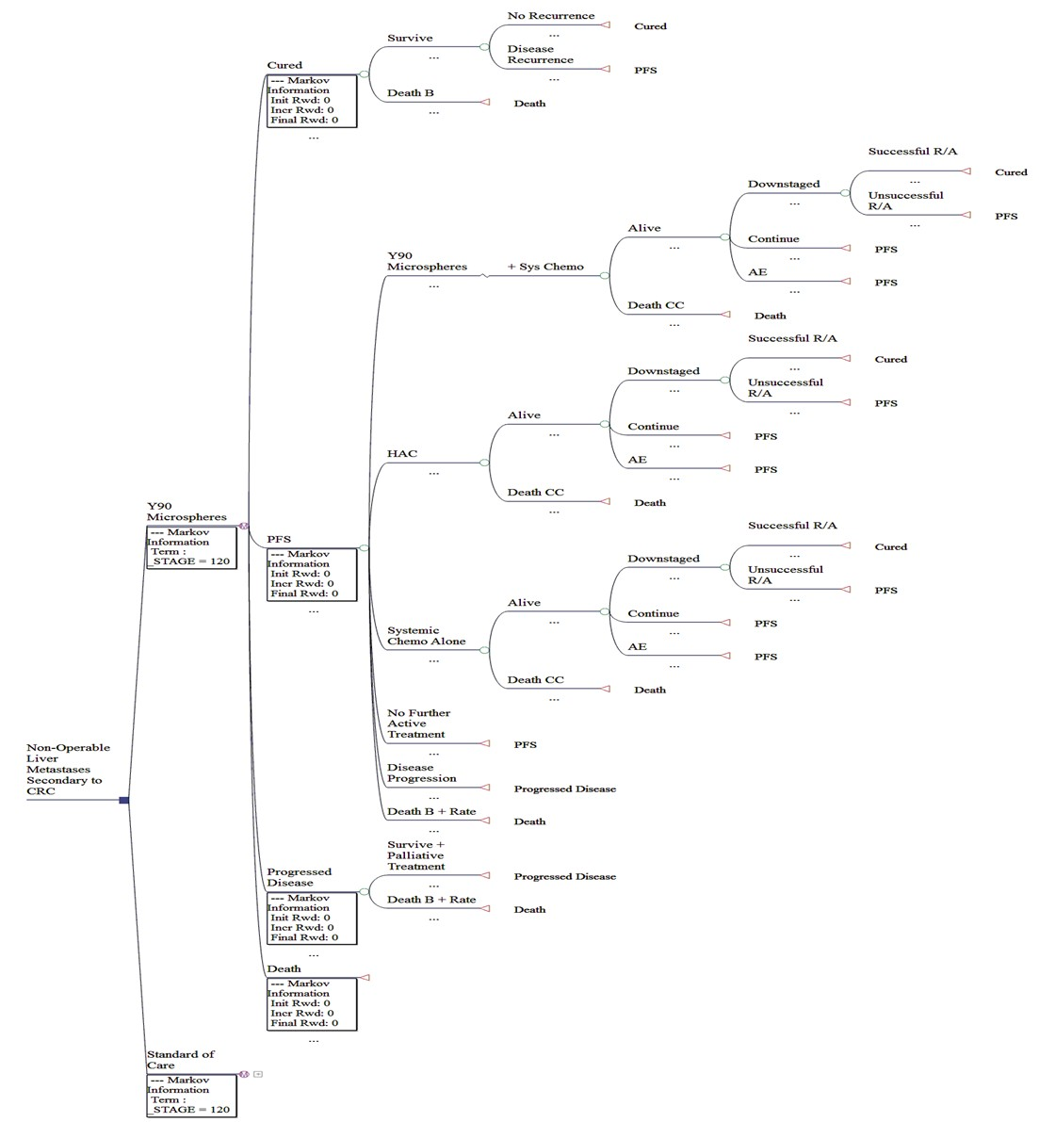

The Markov model takes a similar approach in many areas as that presented earlier for patients with HCC. It is simplified and without any transition probabilities or payoffs at this stage. Cycle length and time horizon are not yet determined.
The structure models a decision between two Markov trees; one tree includes treatment with Y90- microspheres and one does not. The main comparator again is assumed to be TACE.

The model health states are the same as those above, namely “Cured,” “PFS,” “Progressed Disease,” and “Death.” All patients with non-resectable, non-ablatable disease begin in the progression free survival (PFS) health state and from there, in the first Markov scenario, active treatments available include radioembolisation with Y90-microspheres (with or without concurrent systemic chemotherapy), hepatic arterial chemotherapy (HAC), and systemic chemotherapy alone. In the comparator scenario the treatments available are the same with the exception that radioembolisation (with or without concurrent systemic chemotherapy) is replaced entirely by TACE. This is a simplification and has some associated uncertainty. Its effect is that TACE is not available in the clinical management algorithm that includes radioembolisation.

Patients flow through the treatments in a similar way as for the indication of HCC and the structure is designed in a way that that enables capture of differences between the treatment arms in OS, PFS, rates of complications and AEs, and differences in the numbers of patients whose tumours are effectively down-staged allowing surgery. Again, the model allows for the possibility that some patients may receive successful surgery (resection or ablation) after having received treatment with radioembolisation or other options. Transition from the “PFS” health state to the “Cured” health state is possible via this down-staging effect. Within the “Cured” health state it is likely that patients will receive higher quality of life scores and face lower likelihood of death; however, disease recurrence is possible which would trigger a return to the “PFS” state. The transition rates to and from this health state are likely to be quite influential on the model results and thus should be properly examined by way of sensitivity analysis.

When receiving treatment with Y90-microspheres in the “PFS” health state the there may be a proportion of patients who also receive concurrent systemic chemotherapy. While incorporation of the additional costs should be straight forward, the model structure may have to be adapted so that proper outcomes result for these patients (particularly if expert consensus is that radioembolisation plus systemic chemotherapy is more effective than radioembolisation alone). This could be approached by way of trackers and logic nodes.

Once treatment with the two main options (radioembolisation or TACE) is received in the “PFS” state there are the possibilities of patients receiving hepatic arterial chemotherapy (HAC) or systemic chemotherapy. These treatments may be accessed by all or only a proportion of patients depending on normal clinical practice in Australia. HAC is often performed using agents such as 5FU, doxorubicin, cisplatin, potentially oxaliplatin, irinotecan, and cetuximab. The patients that access HAC also have the chance of transitioning to “Cured” through a down-staging effect. Likewise patients treated with systemic chemotherapy regimens have this possibility. Systemic regimens in use include FOLFOX6 and FOLFIRI. The number of repeats of active treatment would be limited in each arm of the model to closely reflect clinical practice.

The active treatments will have some effect on patient transition from “PFS” to “Progressed Disease”
according to the strength of the clinical evidence and expert advice received. Once patients reach the

“Progressed Disease” health state there is no possibility to return to “PFS” or “Cured.” “Death” is an absorbing state and all health states have the possibility for transition to “Death” via background rates of death plus an extra rate according to the health state and differing by treatments to reflect the clinical evidence.
Some limitations of the model structure include:

• Bevacizumab is available for use in these patients but it does not feature. The justification is that treatment with bevacizumab treatment is restricted with the wording, “initial PBS- subsidised treatment, in combination with first-line chemotherapy, of a patient with previously untreated metastatic colorectal cancer.” It is likely that bevacizumab will be used earlier in the clinical management algorithm and so its exclusion entails the assumption that many of these patients in practice will have already accessed bevacizumab. This may distort the relative effect of some of the treatments in the model.

• There is no health state representing AEs or complications and so the need to incorporate these as weighted mean transition payoffs may reduce the transparency of the model.

• The incorporation of “Cured” as a health state will be very influential on the results and appropriate data may not be available to reliably inform the transition rates to and from this state.

• Like with the indication of primary hepatic cancer, the model does not adequately represent patients with chemotherapy refractory disease.

• The PASC determined that TACE along with the other treatments identified in the DAP are the appropriate primary comparators and the interim-listed SIR-Spheres could be used as a secondary comparator. The model structure provided is not intended to be used to evaluate this secondary comparison. Rather than a cost-utility analysis a cost-minimisation analysis would be more appropriate against SIR-Spheres since the treatments are essentially identical.

Outcomes and health care resources affected by introduction of proposed intervention

Clinical outcomes

The application states that Y90-microspheres provide a tumoricidal dose of radiation to tumours within the liver leading to objective tumour responses for the patient as measured by treatment related response, time to progressive disease (TPD) and survival with acceptable toxicity. Further it is claimed that Y90-microspheres will produce a similar therapeutic effect to SIR-Spheres, but superior safety outcomes for personnel associated with its handling and administration.

Given that the appropriate comparison is not solely with the interim listed SIR-Spheres but needs to include clinical practice as well, the relevant outcomes and outcome claims will have to be defined. For instance appropriate outcomes for measurement of therapeutic effect may include overall survival

(OS), progression-free survival (PFS), toxicity (via adverse events or hospitalisations or similar), and quality of life. The exact outcomes employed in an economic evaluation will depend on the comparator selected, which in turn depends on the clinical management algorithms, and the evidence available.

During development of the DAP expert advice indicated that substantial trial evidence for radioembolisation is nearly mature and will be forthcoming in the near future. This evidence is likely to inform the MSAC review of the interim listed SIR-Spheres and will also be highly relevant to the current decision for reimbursement of Y90-microspheres.

Health care resources

As the appropriate structure for the decision analytic model is not yet known, the relevant health care resources have not been identified. The sponsor did not identify any health care resources for a comparison of radioembolisation with current clinical practice.

The application states that none of the healthcare resources presented below are expected to change as a consequence of publicly funding the proposed medical service as the service is already provided with SIR-Spheres.

Table 15 details some of the costs not expected to differ between patients administered Y90- microspheres and patients administered SIR-Spheres.

Table 15: Healthcare resources unchanged between SIR-Spheres and Y90-microspheres.
Healthcare resource Change from SIR-Spheres

Investigative Resources

MAA scan no change

Hepatic angiography no change

Drugs

Pre-treatment – H2 antagonist or proton pump no change

Intra-service – pain medication PRN no change

Fluoroscopy tracer no change

Professional Consultation

Referral for treatment from primary care physician no change

Pre-treat consultation with radiologist no change

Hospitalisations

Work up catheterisation no change

Treatment implantation no change

Prostheses

Product is a prosthetic implant class III AIMD no change

These claims are reasonable given that the products are identical. This will be relevant if a cost- minimisation analysis against SIR-Spheres is determined to be the most appropriate approach. One aspect of uncertainty attached to this arises with the MBS items proposed. The application requests listings to match the current items 35404 and 35406 but not 35408. It is uncertain what proportion of patients receive SIR-Spheres via permanent port and, while this issue won’t affect the CMA result for items corresponding to 35404 and 35406, the overall budget impact may be affected if Y90- microspheres do not cover the SIR-Spheres listings completely.

References
The Globocan Project: cancer incidence mortality and prevalence worldwide in 2008. The World
Health Organisation. http://globocan.iarc.fr/

Surveillance, Epidemiology, and End Results (SEER). US National Institutes of Health. http://seer.cancer.gov/
Cancer Council Australia. http://www.cancer.org.au/home.htm

Australian Institute of Health and Welfare (AIHW). http://www.aihw.gov.au/

Australasian Association of Cancer Registries (AACR). http://www.aihw.gov.au/cancer-aacr/

Gray BN, Colorectal cancer; Natural history of disseminated disease – A Review. Australian and New
Zealand Journal of Surgery. 1980; 50: 643-646.

Brown DB, et al., for the SIR Standards of Practice Committee. Quality improvement guidelines for transhepatic arterial chemoembolization, embolization, and chemotherapeutic infusion for hepatic malignancy. Journal of Vascular and Interventional Radiology. 2009; 20:S219–S226
Lewandowski RJ, et al., Radioembolization with 90Y Microspheres: Angiographic and Technical
Considerations. Cardiovascular and Interventional Radiology. 2007 Jul-Aug;30(4):571-92.

Kennedy A, et al., Recommendations for radioembolization of hepatic malignancies using yttrium-90 microsphere brachytherapy: a consensus panel report from the radioembolization brachytherapy oncology consortium. International Journal of Radiation Oncology Biology Physics. 2007 Vol. 68, No. 1, pp. 13–23.
Wang S-C, Bester L, Burnes JP, Clouston JE, Hugh TJ, Little AF, Padbury RTA, and Price D, Clinical care and technical recommendations for 90yttrium microsphere treatment of liver cancer. Journal of Medical Imaging and Radiation Oncology 54 (2010) 178–187.
Brown DB. et al., Society of interventional radiology position statement on chemoembolization of hepatic malignancies. Journal of Vascular and Interventional Radiology. 2009; 20:S317–S323
Bruix J, Sherman M. Management of hepatocellular carcinoma: an update. Hepatology 2011. 53, 3. Sangro B, Salem R, Kennedy A, Coldwell D, Wasan H. Radioembolization for hepatocellular carcinoma
a review of the evidence and treatment recommendations. American Journal of Clinical
Oncology 2011 Aug;34(4):422-31.

Liapi E, and Geschwind J-F. Combining antiangiogenesis treatment and chemoembolization.
Endovascular today. 1 January 2011

